Development of physical discomfort of airline pilots during prolonged sitting
P Vink¹ , S Anjani¹, M Netten¹, H de Ree², A de Haan² & Y Song¹
¹Delft University of Technology, Faculty of Industrial Design Engineering, The Netherlands
²KLM Royal Dutch Airlines, The Netherlands

ABSTRACT
Discomfort was recorded by 26 airline pilots during flight. Thirteen reported their discomfort during a long haul flight and 13 completed the questionnaires during short haul flights. Discomfort values increased with time to high values, but with a modest decrease towards the end of the flight. Most discomfort was reported in the low back area. For the short haul flights upper back values were high and for long haul flights the buttock showed high values.
KEYWORDS
Discomfort, prolonged sitting, airline pilots

Introduction
During prolonged sitting, occupants increase their discomfort irrespective of how good their seat is (Mansfield et al. 2020). Improvements in contouring of the seat, seat pan angle, the backrest angles, lumbar support and neck support and foam can help in maximising the comfort (Vink, 2016). However, discomfort will increase over time anyhow (e.g. Sammonds et al., 2017), even in a business class passenger seat (Smulders et al., 2016). There are indications that high levels of musculoskeletal discomfort among symptom-free workers may develop into musculoskeletal pain in the long term (Hamberg et al., 2008). For instance, if workers had day after day a cumulative LPD (Local Postural Discomfort) rating of over three, they had an increased risk of neck injuries (RR 2.35) after three years, which means 2.35 times more than the ‘normal’ population. After a few hours of sitting most drivers and passengers, need to take a break and walk in order to provide relief (Mansfield at al. 2020). However, standing up from sitting and walking around is often impossible in occupations like drivers and airline pilots. This prolonged sitting position can be problematic for airline pilots. However, there are not much data available on the increase in discomfort and how discomfort develops in short haul and long haul flights. These data can be useful in the redesign of the flight deck and seat. In this study the amount and location of discomfort is studied.
The data could also be useful for discomfort knowledge as there are not many studies with participants that sit for around seven to eight hours consecutively. Bouwens et al. (2017) studied the comfort among long haul flight passengers, and 149 passengers were interviewed only after their flight. Nine passengers were asked to complete questionnaires during the flight. Interestingly, in this study the discomfort increases, but towards the end of the flight the discomfort decreased. Smulders & Vink (2021) report that more studies show that there is an anticipatory effect towards the end of a long time sitting reducing the discomfort towards the end of the session. Li et al. (2017) followed 18 participants sitting 3 hours and saw a significant increase in discomfort. For the participants sitting in the 28” pitch the discomfort kept increasing, also in the end, but for the 30” and 32”, it did not increase anymore after 2 hours. Pitch is the horizontal distance between seats from a point in the seat to the exact same point of the seat behind it.
There are some data available on complaints among airline pilots. For instance, Froom et al (1986) reported that musculoskeletal complaints in the low back are common among the flight deck crew. Lusted et al. (1994) reported that most complaints of pilots are located in the lower back and buttocks. After 5 hours and 20 minutes 168 complaints were reported on the buttocks by 196 pilots and 143 complaints were reported on the lower back. This was followed by the thighs by 81 complaints and the head/neck (60 complaints). Apart from musculoskeletal discomfort also other complaints have been reported by pilots. For instance, Lindgren et al. (2006) reported as the most common symptom fatigue (14%). Pilot seats are designed according to aircraft manufacturer specifications. These specifications have not changed. Pilot seats have to be designed for pilots of stature between 157 and 191 cm. Adjustment features have to assure pilot sitting comfort. Fairly recently studies have been undertaken to explore further improvements in the design of pilot seats.
This study is on discomfort. There are several interpretations of comfort and discomfort. Some state that discomfort and comfort are two opposites on the same line. Ahmadpour (2014) found no differences between the underlying themes of comfort and discomfort. She states that this implies that both could be described using the same set of themes. On the other hand, many authors (e.g. Looze et al. (2003); Helander & Zhang, 1997) state that comfort is more related to psychological and emotional terms, while discomfort is more connected to physical aspects. In this paper, we assume that indeed discomfort is more related to physical factors.
The research question for this paper is: how is discomfort developing in short haul flights and long haul flights and which areas in the human body are affected?

Methods
To answer the research question 26 pilots were asked to complete a questionnaire consisting of questions on discomfort. Questionnaires were completed during 13 short haul and 13 long haul flights. The short haul flight data were recorded on an outbound flight followed by an inbound flight in a Boeing 737 with a 35-60 minute turnaround time. The long haul flight data were recorded in a Boeing 777 or 787 only during an outbound flight or an inbound flight. In this study, there were always two pilots in the cockpit (a captain and a first officer). Flights were selected without relief crew. So, there was no rest outside the flight deck seat (in bunk or passenger seat).
Approval from the ethical committee of the university was given. Additionally, the study design was discussed with and approved by participating airlines and pilot unions. Participating pilots were given assurance about confidentiality and that no personal data would be recognizable in the final report. Data of individuals are only stored at the TU-Delft servers and accessible to TU-Delft researchers. Other parties only have access to the data on group level. The questionnaires were completed at times that participating airline pilots themselves regarded as safe.
The questionnaires were completed during the flight to avoid the influence of human memory. All pilots were briefed in the crew centre before the flight and a package of questionnaires on paper was handed out with the instruction when and how to complete the questionnaires. The research protocol was verbally explained. The pilots were asked to complete the questionnaire before the flight in the crew centre, sitting in the seat before take-off (0h), after an hour (1h),then approximately each hour during the flight and lastly, at the end of the flight while still sitting in the seat. In the first part of the questionnaire general data were gathered like height, weight and gender. In all question-naires local postural discomfort had to be scored on a body map. Discomfort was chosen as it is related to physical complaints (Hamberg et al., 2008). A body map was chosen to see what specific areas are affected. A Local Postural Discom-fort (LPD) body map was used to score discomfort based on the map of Grinten and Smitt (1992). In the pre-test, the pilots mentioned that the flank sides of the trunk need attention too and this was added to the body map. In each body part (see figure 1) the pilots had to score discomfort on a scale 0-10 (0 = no discomfort at all; 10 = extreme discomfort). An overview of all comfort questionnaires by Anjani et al. (2020) suggest that this questionnaire is suitable for this type of research.
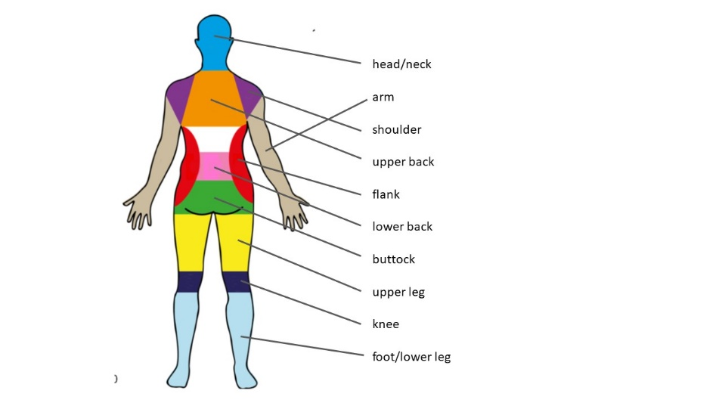 Figure 1: The body map that had to be completed by the pilots approximately every hour.

The fact that the pilots completed the questionnaire at times that they regarded as safe has the consequence that not all questionnaires will be completed at the same time. In addition, in the Boeing 737 the outbound flight was between 1.5 and 3 hours. Then a break of 35-60 minutes in which they do flight preparation for the inbound flight while sitting in the cockpit, and then an inbound flight of between 1.5 and 3 hours to home base. This means also that there is two times a take-off and landing in the 6-8 hour recording. For these flights the recordings were combined by taking the start recording (outbound 0h), the outbound recording at approximately 1:30 hours, 2:30 hours and at destination (3h). Inbound flight recordings started after take-off approximately at 4:45 h, then 5:45, 7:10 and after the flight approximately 7:40s. In the Boeing 787/777 long haul flights there is only one take-off and landing in the six to ten hours recording. Then the pilots go out of the airplane to a hotel, before taking the inbound flight and this is treated as a separate flight. Because of the differences in time of recording in these flights, the data were edited and placed in categories. The first recording was always the same, but then the data were placed in a category of around 1 hour, 2 hours etcetera. This means that there will be missing data in some categories as pilots were not able to complete at certain times.
For the short haul flight and the long haul flight, the total discomfort (sum of all regions on the map of fig. 1) was calculated for each time category and each pilot. The sum over one region was calculated and averaged over the 13 pilots. Additionally, the total discomfort was calculated for each pilot and the average and standard deviation over the 13 pilots is calculated. In order to determine whether discomfort scores differ significantly between the different time categories a Kruskal–Wallis test using IBM SPSS® 25 was used.

Results and discussion
The long haul flight pilots had more flight hours and less complaints (see table 1), which could be caused by a selection bias (pilots with complaints drop out) or that pilots found a way to deal with it or that the 777/787 has more movement space.
Table 1: Overview of data of the short haul and long haul flights
The groups differed on several aspects. The long haul group is on average older, has more flying experience, is taller, heavier, has less female pilots and has fewer complaints before the flight.

Figure 2: Summed discomfort of all body regions averaged over 13 airline pilots during the flight. The horizontal axe shows time intervals of one hour. Final recording was on average at 8 hours, but varied from 7h40-9h50 dependent on the flight duration. ob=out bound; ib =in bound; h=hours.

Figure.3: Summed discomfort of all body regions averaged over 13 airline pilots during flight. The horizontal axe shows time intervals of one hour. h=hours.
In figure 2 and 3 the development of discomfort in time for the short haul and long haul flights are shown. The variation between the pilots is high as is shown by the large standard deviation in the figures. In both the short haul and long haul flights, the sum of the discomfort ratings averaged over the pilots reaches a score of 15. There is the risk of developing musculoskeletal injuries when these values continue over three years. Interesting is the fact both groups already had high discomfort scores before the flight, but the percentage of complaints among 737 is much higher (72% vs 50%).
The Kruskal-Wallis test showed for the short haul 737 flight only significant differences between the two highest values (ib 5:45 and IB 7:10) compared with the start discomfort (OB 0h) (H(7)=17.12, p=0.017). The same is true for the long haul flight; the two highest values (7h and 8h) differ significantly with the lowest (0h) (H(7)=14.55, p=0.042). The phenomenon that the discomfort drops at the end of the flight for passengers (Smulders & Vink, 2021) is seen in airline pilots as well probably because they know that they will be out of the seat within a short while.

(a) (b)
Figure 4: Discomfort for the different body regions for (a) short haul and (b) long haul flights. The horizontal axes is the total discomfort summed over all times.
For both the long haul and short haul flights the lower back region shows highest discomfort, which corresponds to the study of Lusted et al. (1994). If we compare the regions in the body that show discomfort (see figure 4), the short haul flights have more upper back discomfort, while the long haul flights show more complaints in the buttocks. It could be that in the Boeing 737 there is less space leading to a more restricted posture and discomfort in upper back. General comments by the 777/787 pilots were that the seat pan was hard (nine pilots). This hard seat could explain the buttock discomfort. During the long haul flights, the pilots sit very long. There is not a small break at destination, which might lead to higher discomfort in the buttocks. The 737 pilots mentioned (8x) that the lower back was unsupported, and the armrest is difficult to adjust (6x). In redesigning the seat, the seat pan hardness and lumbar support need attention.
Conclusion
The main findings in this study are: (1) Physical discomfort increases during the duty and decreases somewhat close to the end. (2) Physical discomfort in several participating pilots reaches values that may lead to injuries in the end. (3) The body regions that are mainly affected are the lower back in both pilot groups and upper back in the short haul and the buttocks in the long haul pilots.

References
Ahmadpour, N., Robert, J. M., & Lindgaard, G. (2014). Impact of the seat on aircraft passenger comfort experience in the cabin interior. Advances in Ergonomics in Design, Usability & Special Populations (Part II). AHFE International, 603.
Anjani, S., Kühne, M., Naddeo, A., Frohriep, S., Mansfield, N., Song, Y., & Vink, P. (2021). Preferred comfort questionnaires for product design. Work, 68l S19–S28.
Bouwens, J., Tsay, W. J. J., & Vink, P. (2017). The high and low comfort peaks in passengers’ flight. Work, 58(4), 579-584.
Froom, P., Barzilay, J., Caine, Y., Margaliot, S., Forecast, D., Gross, M. (1986). Low back pain in pilots. Aviat Space Environ Med, 57, 694-695.
Grinten, M.P. van der, Smitt, P. (1992). Development of a practical method for measuring body part discomfort. In: Kumar, S. (Ed.), Advances in Industrial Ergonomics and Safety IV. Taylor & Francis, London, 311–318.
Hamberg-van Reenen, H. H., Van Der Beek, A. J., Blatter, B. M., Van Der Grinten, M. P., Van Mechelen, W., & Bongers, P. M. (2008). Does musculoskeletal discomfort at work predict future musculoskeletal pain?. Ergonomics, 51(5), 637-648.
Helander, M. G., & Zhang, L. (1997). Field studies of comfort and discomfort in sitting. Ergonomics, 40(9), 895-915.
Li, W., Yu, S., Yang, H., Pei, H., & Zhao, C. (2017). Effects of long-duration sitting with limited space on discomfort, body flexibility, and surface pressure. International Journal of Industrial Ergonomics, 58, 12-24.
Lindgren, T., Andersson, K., & Norbäck, D. (2006). Perception of cockpit environment among pilots on commercial aircraft. Aviation, space, and environmental medicine, 77(8), 832-837.
Looze, M. P. de, Kuijt-Evers, L. F., & Van Dieen, J. A. A. P. (2003). Sitting comfort and discomfort and the relationships with objective measures. Ergonomics, 46(10), 985-997.
Lusted, M., Healey, S., & Mandryk, J. A. (1994). Evaluation of the seating of Qantas flight deck crew. Applied ergonomics, 25(5), 275-282.
Mansfield, N., Naddeo, A., Frohriep, S., & Vink, P. (2020). Integrating and applying models of comfort. Applied ergonomics, 82, 102917.
Sammonds, G. M., Fray, M. & Mansfield, N. J. (2017). Effect of long term driving on driver discomfort and its relationship with seat fidgets and movements (SFMs). Applied ergonomics, 58, 119-127.
Smulders, M., Berghman, K., Koenraads, M., Kane, J. A., Krishna, K., Carter, T. K., & Schultheis, U. (2016). Comfort and pressure distribution in a human contour shaped aircraft seat (developed with 3D scans of the human body). Work, 54(4), 925-940.
Smulders, M. & Vink, P. (2021). Human behaviour should be recorded in (dis) comfort research. Work, 68, S289–S294.
Vink, P., (2016). Vehicle Seat Comfort and Design. Pumbo: Zwaag.

