Towards a comfortable eco airplane interior
P. Vink¹, G. Vledder², X. Yao², Y. Song², N. Mansfield³, B. Herbig⁴, A.S. Reichherzer⁴, A. M. Bellmann ⁵
¹VHP human performance, The Hague, the Netherlands
²Faculty of Industrial Design Engineering, Delft University of Technology, Delft, the Netherlands
³Nottingham Trent University, Nottingham, UK
⁴Ludwig-Maximilians-Universität München, Munich, Germany
⁵Institut für technische und angewandte Physik GmbH, Oldenburg, Germany

Abstract
Many new future sustainable aircraft concepts have (electric) propeller propulsion. However, the noise and vibration generated by propeller propulsion might create discomfort for passengers. In the Clean Sky 2 project ‘ComfDemo’, all factors influencing comfort and discomfort are studied, with the aim to improve comfort experience for eco airplanes. The results show that noise, vibration and seat are the most mentioned factors influencing discomfort. The flights without passengers showed different noise characteristics, which makes test flights with passengers inevitable. Noise certainly needs attention, but anthropometrics as well as for instance elbow-elbow width is greater than the 18” seat width for many passengers.

Introduction
Transport should ideally be close to carbon neutral. One form of air transport to realize this is with electric propulsion systems. Alves et al. (2020) state that one of the most significant handicaps of electrical mobility is the low energy density of current batteries. They state that the best approach to tackle that obstacle is through better usage of the amount of stored energy and the propeller is becoming favourable as it is more efficient. Therefore, propellers may have a larger role to play again in future commercial aviation. In the short term the turboprop might also be a solution as it is more efficient than a jet on regional flights. Travelling by jets for short flights (less than 750 km) is relatively more polluting as during taxi, take-off and landing there is much CO₂ emission (Hendrikx, 2021)).
Turboprops using SAF (Sustainable Aviation Fuel) could result in a further reduction of CO₂ emissions (Babikian et al., 2002). We can get even closer to zero- carbon emission as some current cargo turboprops will be adapted using hydrogen conversion kits (Mandel, 2021), which includes a fuel cell and an electric powertrain to replace conventional turboprop engines.
However, the turboprop might have an image issue. In a study on travel preference participants complained about the outdated image of turboprops (Vink et al., 2022).
Fig. 1. The boarding of the participants in the turboprop for one of the two test flights
Another problem is that the noise and vibration generated by propeller propulsion create discomfort for passengers and might reduce the number of passengers choosing to travel on propeller-driven aircraft. It is interesting to know how large this noise problem is and if it can be solved.
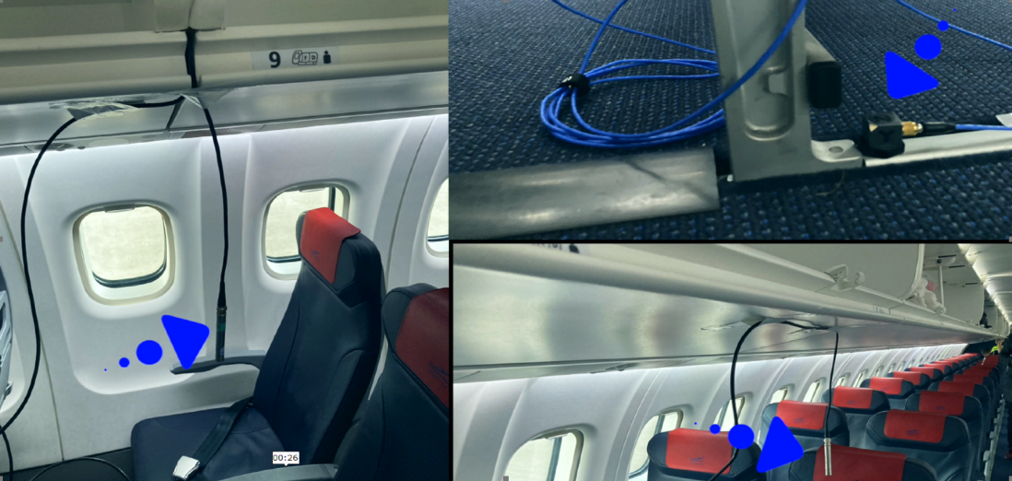
Fig.2. Sensors recording the environmental characteristics placed in the aircraft
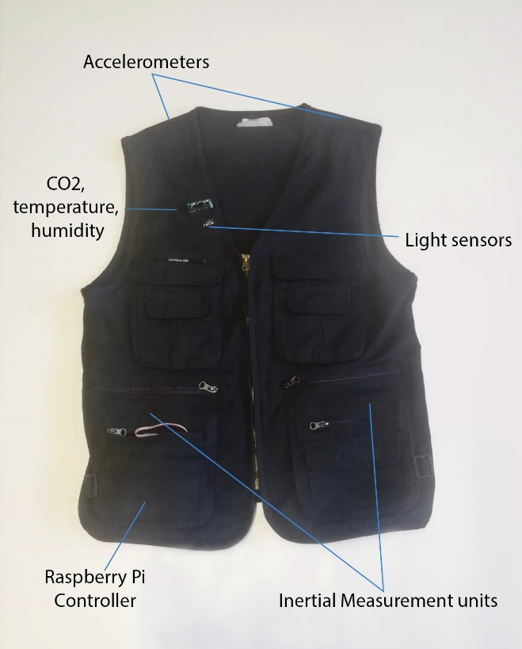
Fig.3. the jacket that participants wear during the flight test recoding locally close to the passenger the environmental characteristics
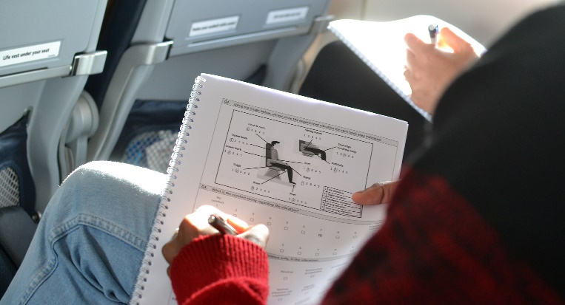
Fig.4. participants completing questionnaires

Method
In the Clean Sky 2 project ‘ComfDemo’ (see www.comfdemo.com), many factors influencing comfort and discomfort are studied, with the aim to improve comfort experience for eco airplanes. Two flights with a turboprop airplane were made (see fig. 1) and factors influencing comfort were recorded, including noise at various positions in the airplane (see fig. 2), vibration, temperature, seat dimensions versus anthropometrics, CO₂, humidity and passenger movement. High quality equipment was used as well as an instrumented jacket (see fig. 3) worn by the passengers recording their local environment. Additionally, 94 passengers (mean age 33.86 ± 14.31 years, 58 men and 36 women, mean BMI 23.60 ± 3.24) completed questionnaires (see fig. 4) on comfort and wellbeing factors at various moments during the flights. Apart from the two flights with passengers an additional flight was arranged without passengers and the environmental characteristics were recorded again.

Results and discussion
The results show that noise is the most mentioned factor influencing discomfort (Vink et al., 2022b). This noise issue in a turboprop has been reported earlier in other studies by for instance Mansfield et al. (2021). Interesting is that the recorded noise (dB) was highest in the middle of the airplane (see fig. 5), but this effect was not as clearly reported by the passengers’ questionnaires. Perhaps the frequency spectrum also plays a role. This is important to study further as it might influence the choice of measures to reduce the noise experience. It might also be good to look at the noise in the different flight phases and study measures to reduce the experienced noise like the position and type of power source and number of blades. The noise experience could also be influenced by using electric taxiing systems or shorter taxi times, better sound insulation or noise cancelling (e.g. headphones).
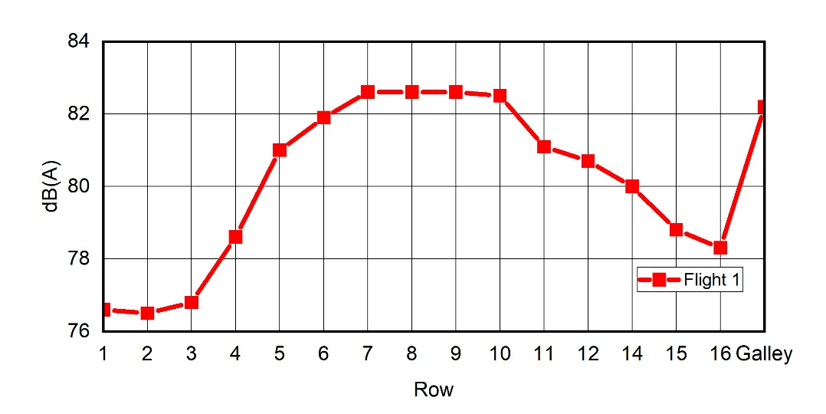
Fig. 5. The recorded dB in different rows of one of the flights in the airplane (Müller et al., 2022).
Passenger responses were different during the different flight phases. Flights without passengers and just crew showed different noise characteristics, which makes sense as passengers might have an acoustic damping effect, and passenger activity/speech also causes sound in occupied flights. It shows that test flights should also be done with passengers to gain data applicable to real flights. The vibration and anthropometrics/seat where the 2nd and 3rd most influencing factor related to discomfort (Vink et al., 2022b). There was continuous vibration throughout the flight directly related to the engine and propeller speed, combined with intermittent motion caused by turning and turbulence. There was also significant noise and vibration during taxi. Regarding anthropometrics/seat, the discomfort increased during the flight. This phenomenon has been described before and even in business class seats the discomfort increases in time (Smulders et al., 2016).
The seat width was 18”, which is comparable to other economy class seats in for instance the A320 series (Anjani et al., 2021). It means that passengers will have shoulder contact. However, there are aircrafts seats of 17” wide as well, which might have a bigger problem regarding shoulder contact. In the literature there are studies that show that taller passengers have more discomfort, especially passengers with lengthy upper legs or wide hips (Anjani et al., 2020). The hip width will be an issue in the future if trends continue, as the last 30 years the 95th percentile female hip width increased 30 mm to 434 mm among Dutch students (Molenbroek et al. 2017). The p95 hip breadth sitting of the international population in Dined (www.dined.nl) is 436 mm. The anthropometric data in ISO 7250-2 (ISO, 2010) show that males' average shoulder breadth is 103 mm wider than their seated hip breadth and that females’ shoulder breadth is 44 mm greater than their seated hip breadth. In the study of Molenbroek et al. (2017), the shoulder width is now 467 mm for 95th percentile female and 500 mm for 95th percentile male Dutch students. Compared with current 17” wide (432 mm) and 18” wide (457 mm) seats it is clear that many passengers will not fit sitting shoulder to shoulder. In fact the problem is larger as elbow width is even more wide, but not often recorded in anthropometric data bases.
What was interesting in this study is that not many passengers mentioned the old fashioned image of the turboprop, which was mentioned in another study (Vink et al. 2022a). That was probably influenced by the bright good looking interior and the service of the crew. However, it could also be a bias of the group as they were volunteers and registered themselves as a participant for a turboprop flight. Further data could be obtained with real passengers to test this, or through use of aircraft cabin simulators.

Conclusion
To attract more passengers in future propeller driven airplanes attention is needed for noise, vibration and fitting the seat to the future anthropometrics. This can be assisted by design of position and type of power source, number of blades, using electric taxiing systems, better sound insulation or noise cancelling (e.g. headphones). The seat design could be more spacious for future aircrafts.

Acknowledgement
This project has received funding from the Clean Sky 2 Joint Undertaking (JU) under grant agreement 945583 (ComfDemo).

References
Alves, P., Silvestre, M., & Gamboa, P. (2020). Aircraft Propellers—Is There a Future?. Energies, 13(16), 4157.

Anjani, S., Li, W., Ruiter, I. A., & Vink, P. (2020). The effect of aircraft seat pitch on comfort. Applied Ergonomics, 88, 103132.
Anjani, S., Song, Y., Hou, T., Ruiter, I. A., & Vink, P. (2021). The effect of 17-inch-wide and 18-inch-wide airplane passenger seats on comfort. International Journal of Industrial Ergonomics, 82, 103097.
Babikian, R., Lukachko, S. P., & Waitz, I. A., 2002. The historical fuel efficiency characteristics of regional aircraft from technological, operational, and cost perspectives. Journal of Air Transport Management, 8(6): 389–400.
Hendrikx, R., 2021. A service design vision for air-rail journeys: Stimulating travellers to make a more sustainable choice by integrating international trains and flights. MSc thesis TU-Delft.
ISO, 2010, ISO TR 7250-2:2010 Basic Human Body Measurements for Technological Design – Part 2: Statistical Summaries of Body Measurements from National Populations, ISO, Geneva, Switzerland (2010)
Mandel, E., 2021. ASL Aviation, Universal Hydrogen to convert ATR 72 cargo aircraft to hydrogen, https://www.h2bulletin.com/asl-aviation-universal-hydrogen-to-convert-atr-72-cargo-aircraft-to-hydrogen/
Mansfield, N., West, A., Vanheusden, F., & Faulkner, S., 2021. Comfort in the Regional Aircraft Cabin: Passenger Priorities. In Congress of the International Ergonomics Association (pp. 143-149). Springer, Cham.
Molenbroek, J. F. M., Albin, T. J., & Vink, P. (2017). Thirty years of anthropometric changes relevant to the width and depth of transportation seating spaces, present and future. Applied ergonomics, 65, 130-138.
Müller, B., Lindner, A, Norrefeldt, V, Song, Y, Mansfield, N, Vink, P, 2022. Measurement of noise and indoor climate on board a turboprop airplane flight, paper at ICAS2022 Stockholm, Sweden
Smulders, M., Berghman, K., Koenraads, M., Kane, J. A., Krishna, K., Carter, T. K., & Schultheis, U. (2016). Comfort and pressure distribution in a human contour shaped aircraft seat (developed with 3D scans of the human body). Work, 54(4), 925-940.
Vink, P, Vledder G, Monteiro LR, Song, Y, 2022a. Passenger reasons for mobility transition from jet to train and turboprop. Aeron Aero Open Access J. 2022;6(4): 6 (4), 118‒121
Vink, P., Vledder, G., Song, Y., Herbig, B., Reichherzer, A. S., & Mansfield, N., 2022b. Aircraft interior and seat design: priorities based on passengers’ opinions. International Journal of Aviation, Aeronautics, and Aerospace, 9(1), 3.

