Oversimplification issues in social sciences research models

Barbara van Veen^{1*}, Roland Ortt¹

Abstract
Organizational responses to strategic surprises such as the credit crunch in 2008, the pandemic in 2020, and the current climate problems are increasingly reliant on scientific insights. As a result, the accuracy of our models has become more critical than ever, and our models have become more and more complex to capture the real-world phenomena we study as best as they can. So much, so that appeals for simplification are beginning to surface. But unfortunately, simplification has its issues.

Too simple models are so generic that they no longer accurately describe or predict real-world cause-effect relationships. On the other hand, too complex models are accurate for a specific context and are difficult to generalize. Somewhere on the continuum between too simple and too complex lies the optimal model.

In this article, the authors contribute to the ongoing discussion on model complexity by classifying the problems when there is a mismatch between real-world and model complexity. They present a framework of four levels of model complexity and possible oversimplification problems per level.

The framework can help scholars within the social sciences to detect possible oversimplification from literature reviews and inform choices for either in- or decreases in model complexity.

Keywords
Complex causal models, oversimplification, social sciences, organizational research, weak signals, innovativeness

¹ Technology, Policy and Management, Delft University of technology, Delft, The Netherlands
* E-mail: B.L.vanVeen-2@tudelft.nl (BV)

Introduction

Models are a balancing act between a valid representation of complex real-world phenomena and valid research through a focus on and isolation of (parts or dimensions of) phenomena. Unfortunately, despite the rigor with which models are developed, focus and isolation can lead to an implicit downward spiral towards severe oversimplification. At the individual study level, this may lead to new models developed on the quicksand of seemingly similar models. This can lead to myopia, confusion, and wrong notions at the overarching level of theory and knowledge building. The social sciences exhibit several examples of severe oversimplifications, and two of them underpin the classification and determination tool detailed in this paper.

Since the world wars in the previous century, policymakers have turned to science for insights into and solutions for societal challenges. In our century, governmental and organizational responses to climate changes, the pandemic, or the invasion of Ukraine made the direct links between science and politics all the more visible. Such direct links emphasize the significance of the real-world validity of research and, thus, the significance of avoiding oversimplification. The conceptualization of tools to determine and classify oversimplification in models and disciplines form an urgent and relevant step in addressing problems with real-world validity.

We induced a classification table from two examples of two-variable models in two disciplines. We assumed that problems with the most straightforward, simple models would translate to more complex models. We also assumed that findings from disciplines that are each other’s opposites in terms of maturity but equal in their focus on managerial behavior and model simplicity would lead to generalizable insights.

A standard and straightforward model is the relationship in which one phenomenon affects another. The model distinguishes between a variable representing a phenomenon acting as a cause, a variable representing a phenomenon acting as an effect, and a link between variables representing the effect from one phenomenon on the other (see Figure 1).

Figure 1. A model of phenomenon 1 serving as a cause (represented by variable V1), phenomenon 2 serving as an effect (represented by variable V2), and the effect from phenomenon 1 on phenomenon 2 (represented by relationship V1-V2)

A closer look at such models may reveal oversimplification in three components:
- First, phenomena. When a phenomenon is one-dimensionally defined, the actual construct may be multi-dimensional. Oversimplified phenomena can unintentionally hide significant dimensions, incompleteness, or overlap of dimensions.
- Second, relationships. When a relationship between phenomena is modeled as a one-sided linear effect, the actual relationship may be two-sided, involve multiple relationships between different dimensions of phenomena, or be non-linear. Oversimplified relationships can unintentionally hide significant facets of a much more complicated relationship from view.
- Third, context. When models are presented in splendid isolation, the actual issue under study may be contingent on contextual conditions not included in the representation. When oversimplified, isolated models omit significant information like moderating and mediating variables, joint causes, multiple consequences, and limitations that emerge from different contexts.

The balance between real-world complexity and model focus is settled during the conceptualization, operationalization, and validation stages. Each stage is completed with academic rigor. Our shared methods to arrive at models are careful, conscientious, and covered with explicit model limitations and caveats. In addition, the rigorous methodological rules give us the confidence to select and combine model parts to induce our model. We strive for elegance: to find the most straightforward model that accurately depicts deep insights and is uncomplicated to test. Peer review does a final check on the quality of decisions made. Nevertheless, individual acts at the level of conceptualization and operationalization of phenomena, relationships, and contexts can still lead to a model unable to reveal the insights we seek, despite the model passing validation tests.

Oversimplification acts like quicksand for subsequent studies. One study's focus and methodological rigor do not protect us from unintended oversimplification consequences when its findings are integrated into the second. Severe model oversimplification will lead to misdirecting results. In turn, these results lead to misrepresentation in the models of subsequent studies. When left unchecked, the body of knowledge we think we are developing is no more than a bag of tentatively related knowledge parts at best.

In the next section, we will briefly discuss the ongoing discussions about the optimal complexity of models and explain our choice to develop the classification framework for two distinct cases (section 2). The first case is from the research domain of innovation diffusion. The second example is from the domain of managerial foresight. Next, the two cases are discussed per component and framework stage (section 3). Finally, the cases’ issues were inductively extrapolated into a classification framework (section 4, table 2). Conclusion and discussion are in section 5.

Background
This section consists of three parts. In the first part (2.1), we will briefly describe the current thinking on model complexity. Then, in the second part (2.2), we will outline our approach, explain why we worked with cases, and clarify our choice of cases. Finally, in the third part (2.3), we conclude with the framework used for classification.

Current Thinking on Model Complexity
We built the classification framework to help scholars avoid oversimplification errors at the level of a single study, its validation, and integration into a larger body of knowledge. The need for such a framework emerges from the ongoing discussion about model complexity. Supporters and opponents of complex models try to find the optimal level of complexity that makes a model easy to understand yet still accurate and informative about the underlying real-world phenomenon. For example, a very complex model may merely inform on a highly context-specific situation, while a straightforward model may not be accurate enough (Del Giudice, 2021; Perkins & Grotzer, 2005).

Problems with modeling have been explored for many types of advanced models like longitudinal growth models (Bliese & Ployhart, 2002), structural equation models (Landis et al., 2000), or models with multiple mediation paths (Taylor et al., 2008), to the point that appeals to reduce model complexity are appearing (Saylors & Trafimow, 2021; Schoenenberger et al., 2017). Unfortunately, insights on avoiding oversimplification are difficult to find. Primarily, insights draw attention to specific types of oversimplification, like the lack of explicating model boundaries (Busse et al., 2017) or problems with integrating mediation and moderation effects (Hayes, 2012; MacKinnon, 2011).

The classification table in section 4 was developed to bring a coherent perspective on simplification issues to the discussion of optimal model complexity.

Using Case Studies to Build Theory
The current thinking on oversimplification in scientific literature is severely fragmented and disjointed. Therefore, we chose to develop the classification framework inductively. Following the seminal work of Eisenhardt and Graebler on using cases for theory building (Eisenhardt, 1989a; Eisenhardt & Graebner, 2007), we chose to explore two diametrical cases.

We selected two case studies from two distinct disciplines of social sciences that can be seen as opposites in field maturity, yet both include a broadly accepted two-variable model. Using an established and nascent discipline reduced the likelihood that the classification emerged as a side effect of either maturity level. Using broadly accepted models may help readers to follow our inductive logic. Using the most basic model of two variables and their relationship allowed for more straightforward problem exploration. Its results can then serve as a reference for exploring more complex models.

The first case describes modeling problems of the innovativeness phenomenon (adoption of new products) from the field of innovation diffusion. The second case describes modeling problems of signal weakness (acceptance of new information) from the domain of organizational foresight. These cases represent the opposite poles of research domains. Innovation diffusion is a mature, clearly demarcated domain with fixed paradigms. Organizational foresight is a nascent domain with fluid paradigms that are hardly separated from its multidisciplinary origins. Nevertheless, analysis of the cases resulted in the emergence of the same issues, suggesting that these were generalizable across organizational and managerial research disciplines.

Innovativeness
A well-known model in the innovation diffusion domain describes innovative individuals' effect on the diffusion of innovations. This model can be seen as one of the most widely used in innovation, management, and technological change. Unfortunately, the model is also severely oversimplified. We will present the model first and then discuss its oversimplification issues.

The model shows how the 'innovativeness of individuals' influences their 'adoption of innovations' (their acquisition of a new product or process) (see Figure 2).

Figure 2. 'Innovativeness of individuals' (represented by variable V1) affects (relationship V1-V2) the adoption of innovations (represented by variable V2)

The model is part of the theory describing the diffusion of innovation, usually called Rogers’ theory. Rogers published the theory in 1962, and the book soon became the norm for innovation researchers and practitioners alike (Rogers, 1983). However, the first formal diffusion models were created by Ryan and Gross. Their model explained diffusion almost exclusively in terms of demand-side phenomena, which were further narrowed down by focusing on the characteristics of potential adopters. The focus allowed diffusion scholars to separate innovators, early adopters, early majority, late majority, and laggards and used the subgroups to explain the emergence of the diffusion curve (Ryan & Gross, 1943).

Their graduate student Rogers extended the model to show the cumulative adoption of an innovation over time with the diffusion curve (see Figure 3). The vertical axis shows the cumulative percentage of adopters. The horizontal axis shows the time scale (usually over several years). On the time scale, subsequent groups of individuals that typically adopt the innovation over time are plotted.

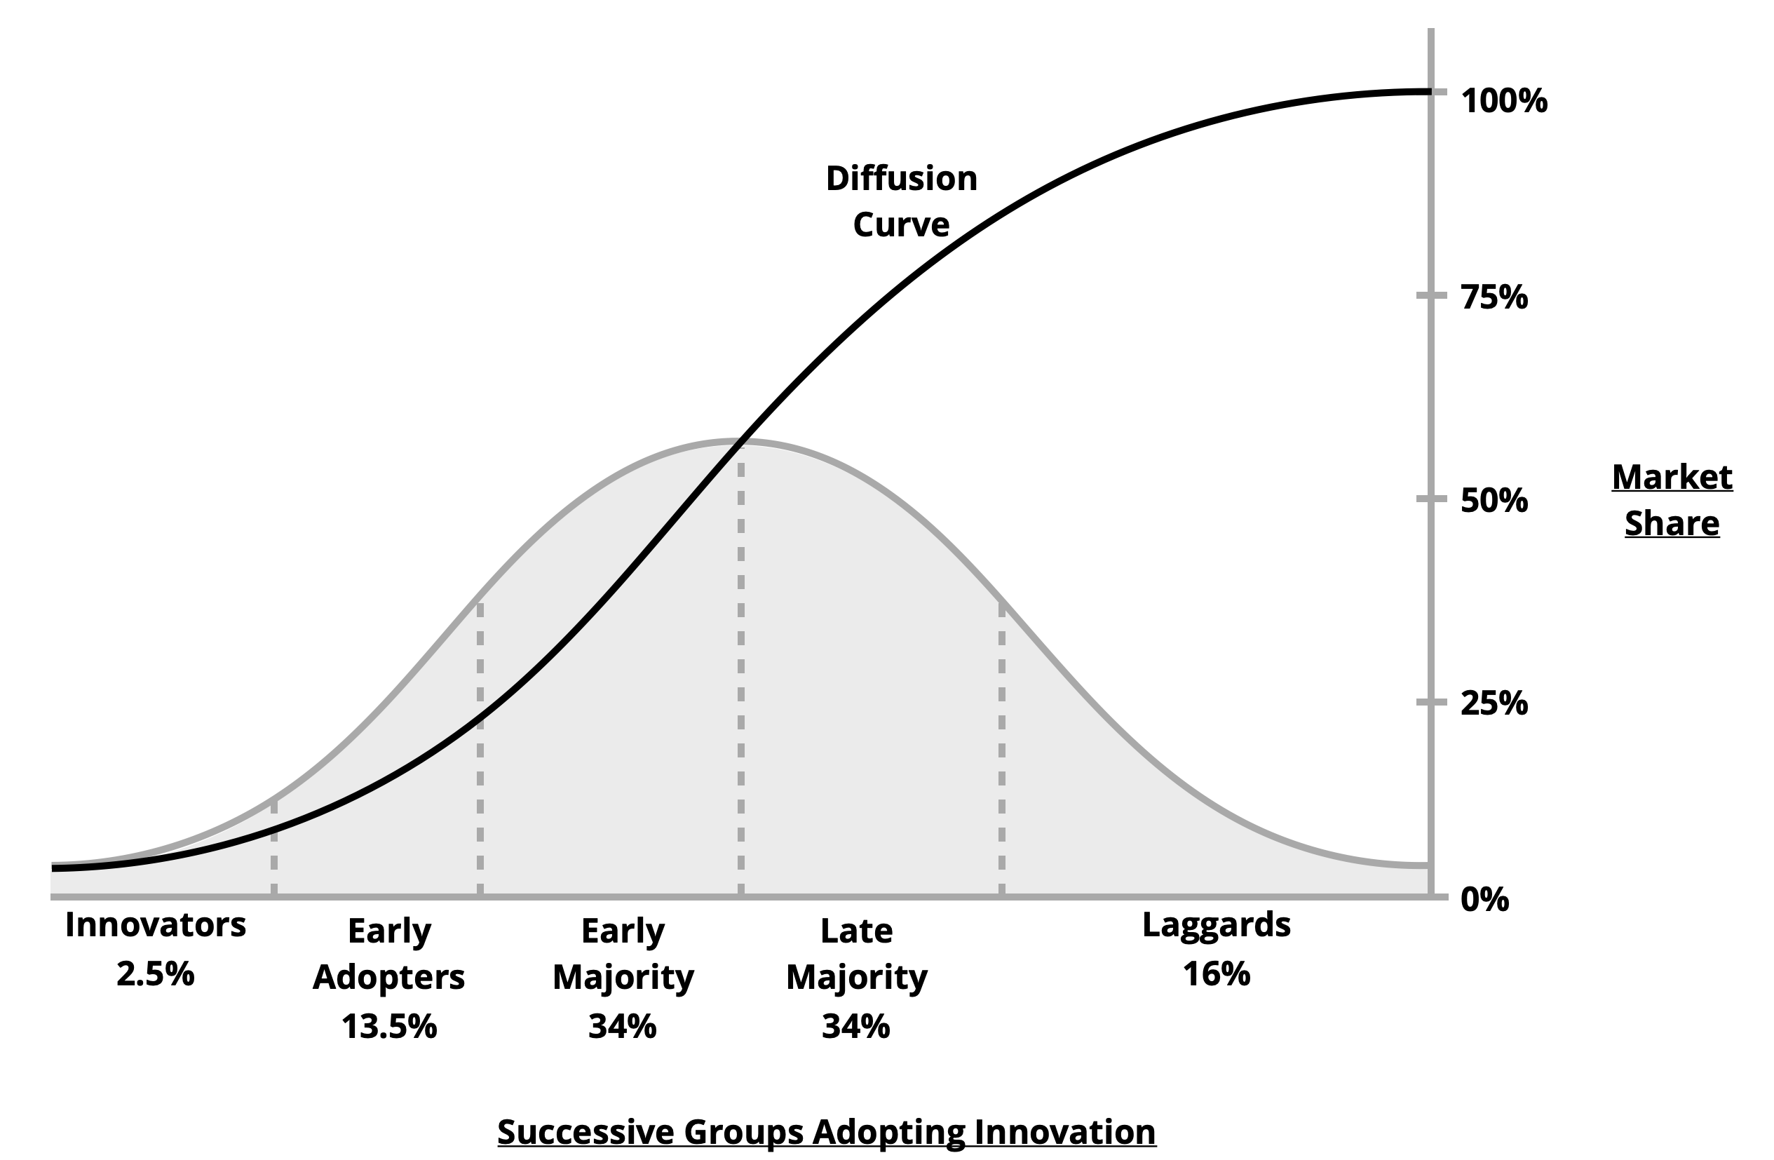

Figure 3. Subsequent adopter groups in the diffusion model

Both figures are straightforward but hide the confusion on what defines innovativeness, how to measure it, and how context specific the model is.

Signal Weakness
Managerial foresight aims to find robust ways to predict changes in the organizational environment and their impacts. One of its research lines focuses on detecting the earliest signals that change is imminent. Such signals are called weak because they are hard to detect, ambiguous, and incomplete. One of the first studies on the phenomenon was done by Ansoff (1975) and is seen as the start of weak signal research. Ansoff also coined the term "weak signal" (Ansoff, 1975, p.23) and described the relationship between the emergence of a change and the progression of knowledge of said change within strategic planning processes (Ansoff, 1979).

As a change emerges, its signals become stronger until the change is perfectly understood. The amplification of a signal and or signals completing each other can lead to higher states of knowledge, or its polar opposite, lower signal weakness (see Figure 4). The rows show the information about an upcoming change, ranging from the 'conviction that change is imminent’ to its ‘consequences in operational results’. The columns show the progression of the state of knowledge, ranging from mere 'sensing a change’ to the knowledge of its first impact. The lines depict growing insight by increasing knowledge levels and decreasing signal weakness, its polar opposite.

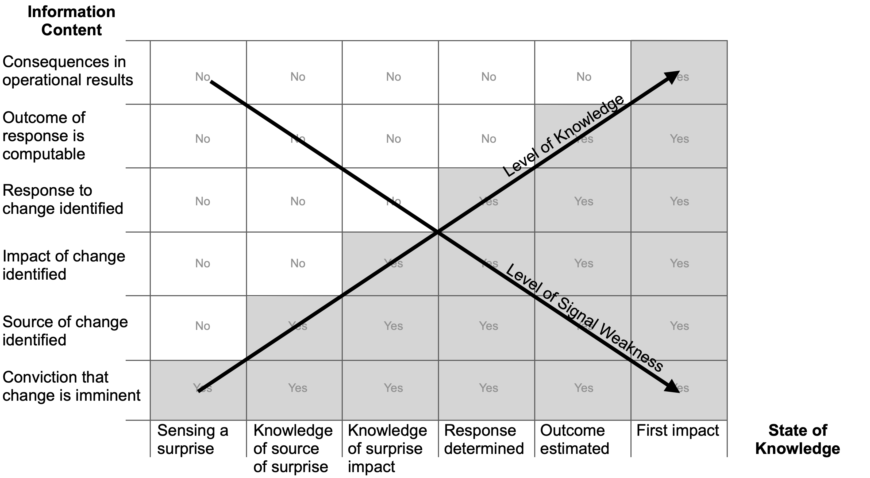
Figure 4. Subsequent states of knowledge over time (adapted from Ansoff, 1979, p.57)

The model still stands and has been enriched with research into methods to elicit early signals of pending surprises (Thorleuchter & Van den Poel, 2015; Yoon, 2012), barriers to signal detection and interpretation (Ilmola & Kuusi, 2006; Lesca et al., 2012), ways to increase the accuracy of signal interpretation (Kaivo-oja, 2012; van Veen et al., 2019), the link between signal interpretation and organizational behaviors and performance (Battistella, 2014; Rohrbeck & Kum, 2018).

Although this model is seen as the foundation of modern research into strategic foresight and planning (Holopainen & Toivonen, 2012), there is a lack of consensus about the phenomena it describes (van Veen & Ortt, 2021).

The Classification Framework
Causal models describe cause-effect relationships between (sets of) variables representing a real-world phenomenon (Wright, 1921). The simplest model has one variable causing an effect on one other variable, occurring independently from the model context. We used these three essential model components (variables, relationships, and context) as the skeleton of the body of issues.

Simplification can occur in each component and becomes oversimplification when the model no longer represents the real-world phenomenon it refers to. For example, suppose the cloud of variables describing a phenomenon is too ambiguous to separate. Choosing a (set of) variables may result in losing significant information and combining variables in high collinearity. Simultaneously, the cause-effect relationship between the selected variables may be linear but multidirectional or curve-linear for a different choice. Finally, the choice may unwittingly be contingent on contextual specifics.

Simplification can occur in two stages: model conceptualization and operationalization. Conceptualization refers to how phenomena, relationships, and contexts are represented and defined in a model with variables and effect relationships. Operationalization describes how the variables and their effects are measured and assessed empirically. Oversimplification can stem from overly simple definitions and measurements.

The following section will discuss the two cases per framework component and stage.

Two Cases Illustrating the Framework Components and Stages
Two cases informed the classification framework: the case of innovativeness and the case of signal weakness. The first case is from the established discipline of innovation diffusion, and the second is from the nascent discipline of managerial foresight. Both cases describe a broadly accepted two-variable model rife with problems of oversimplification. We will discuss the issues per model component and stage, beginning with the variables describing the phenomenon (3.1 Innovativeness and 3.2 signal weakness), then the variable relationships (3.3 and 3.4), and finally, the model context (3.5 and 3.6).

Oversimplification of the Innovativeness Phenomenon
In the case of innovativeness, the variable 'innovativeness of individuals (see Figure 2) is derived from a cloud of aspects that describes the innovativeness phenomenon. These aspects were not separated by natural distinctiveness. Furthermore, aspect diversity made evident logic for splits or combinations hard to develop. In the end, the conceptualization and operationalization of innovativeness were described by the characteristics of the individuals adopting innovation. This appeared to be a severe oversimplification.

Conceptualization of Innovativeness
The division of potential adopters in various groups that, over time, adopt an innovation, as reflected in Figure 3, does not specify whether the innovativeness is an innate trait or a product category-specific characteristic. However, it does assume that individuals are similar within groups and differ between groups of adopters.

Oversimplification already occurs when innovativeness is seen as an innate trait because only the innovativeness of individuals regarding all types of innovations can be innate. In contrast, the innovativeness of individuals regarding a specific product category can be seen as a product category-specific characteristic. Innovative individuals in fashion, for example, do not necessarily have the same characteristics as innovative individuals in computing. We will further focus on product category innovativeness.

Product category innovativeness is often conceptualized as a multi-dimensional construct, but conceptualizations vary widely (Bearden & Netemeyer, 1999). The variety in conceptualizations points towards a second oversimplification during the conceptualization stage of innovativeness. Innovativeness is the tendency to learn about and adopt innovations within a product category. Unfortunately, another variable, namely an individual's knowledge of a product category, shares dimensions with innovativeness (see Table 1).

Table 1. Overlap in the conceptualization of product category innovativeness and involvement

Product category (or domain-specific) innovativeness scale | Product category knowledge scale
Definition (Conceptualization)  An individual's tendency to learn about and adopt innovations (new products) within a specific category. | Definition (Conceptualization)  Amount of information an individual has about innovations (products) from a specific category.
Measurement (Operationalization)  1. Compared to my friends, I own a few products from the category.  2. In general, I am the last in my circle of friends to know the latest products from the category.  3. In general, I am among the first in my circle of friends to buy a new product from the category when it appears.  4. If I heard that a new product from the category was available in the store, I would be interested enough to buy it.  5. I will buy a new product from the category, even if I haven't seen it yet.  6. I know of the products from the category before other people do.  Adapted from Goldsmith and Hofacker (1991) | Measurement (Operationalization)  How much do you know about products from that category compared to friends?  How much do you know about products from that category compared to experts  Adapted from Park et al. (1994)

When two variables referring to different phenomena share dimensions, oversimplification occurs when the phenomena could have been defined and measured independently from each other. For example, suppose individuals with the same level of product category knowledge adopt innovations at different moments. In that case, the two variables could have a differential effect on adoption. However, that effect cannot be explored when the conceptualization and operationalization of both variables overlap.

Operationalization of Innovativeness
The interest in accurately describing innovator characteristics is more than purely academic. After identifying the innovators' profiles, their numbers can be estimated before they adopt an innovation. The number of innovators serves as an estimate of product demands just after market introduction. An oversimplified phenomenon may lead to under or overestimating demand and result in unnecessary organizational challenges.

Innovator characteristics are investigated in diverse product categories, like home computers (Dee Dickerson & Gentry, 1983), residential long-distance telephone services (Warren et al., 1988), and fashion (Summers, 1972). Finally, a recent overview is given by Dedehayir et al. (2020).

Several operationalization issues can be found in these studies. Firstly, innovativeness is sometimes measured post-hoc in terms of actual adoption. In that case, the phenomenon of 'innovativeness of an individual' and the phenomenon' adoption of an innovation' have meshed. The post-hoc assessment of innovativeness is a problem because it makes it impossible to explore the mechanism of innovativeness influencing adoption.

Secondly, innovative individuals are thought to share general characteristics like a young age, cosmopolitan lifestyles or views, and a high level of education. However, these characteristics merely co-evolve with innovativeness rather than represent it. Defining a phenomenon in terms of its co-evolving phenomena is a problem if different co-evolving phenomena can be found for some types of innovativeness. For example, if innovative individuals of a specific product category are older, less cosmopolitan, and comparably lower educated, the definition would have classified the wrong group as innovative.

Oversimplification of the Weak Signal Phenomenon
When a phenomenon is the subject of multidisciplinary research, it combines ideas and findings from significantly different disciplines, each with its research traditions and terms. Across disciplines, the same phenomenon can have different names, conceptualizations, and operationalizations. In the case of weak signals, the early warnings of impactful changes in the organizational environment, the number of definitions exceeds sixty (van Veen & Ortt, 2021).

Conceptualization of the Weak Signal Phenomenon
The phenomenon is called weak signals in Futures Studies (Ansoff, 1979), ill-defined events and trends in Strategic Choice (Jackson & Dutton, 1988), or wicked problems in Sense-Making (Weick, 1995). Each field has conceptualized the phenomenon with multiple dimensions that do not always overlap or are mutually exclusive despite the phenomenal similarity. For instance, a weak signal can refer to information in the broadest sense, an ill-defined trend to a statistical forecast and not much else, and a wicked problem with feelings. In Futures Studies, the phenomenon describes anticipated change. In Strategic Choice it refers to a change that needs a decision, and in Sense-Making, an observed change in retrospect.

Besides applying different names, papers on weak signals also refer to overlapping yet different conceptualizations of the phenomenon. Unfortunately, authors adopt one conceptualization or, more frequently, phenomenal reconceptualization. If the latter happens, a field gains a deeper insight into a particular phenomenon aspect while simultaneously complicating the validation between studies. Reconceptualization hinders validation when the commonalities and differences between conceptualizations remain implicit. If that happens often enough, a field may end up with conceptualizations lacking in common ground.

Some weak signals' conceptualizations refer to the earliest signals' objective quality in terms of incompleteness, correctness, or ambiguity. This can happen when there is hardly any structured data available. Others refer to the objective centrality of early signals within the daily avalanche of news when, for example, various media are picking up on a change. Others again refer to a signal's subjective novelty, as in the difference of knowledge between an inventor and an observer of new technology. It is imaginable that studies on objective phenomena lead to different observations than subjective phenomena. It is also conceivable that weakness could simultaneously refer to these dimensions (see Figure 5).

Figure 5. Part of the variable cloud describes weak signals in which some clusters of variables partially overlap (adapted from Van Veen and Ortt, 2021)

Scholars felt it necessary to bring clarity by developing their definitions. This led to several reviews voicing concerns about the definition abundance, appeals to find consensus on the meaning of weakness (Carbonell et al., 2015; Hiltunen, 2008; Saritas & Smith, 2011), and the rare attempt to suggest a solution (van Veen & Ortt, 2021). Note that these appeals were published over at least 12 years, and the issue remains open.

Another problem that underpins the continuous redefining of signal weakness is the question of the objectivity of the signal. Ansoff did not make explicit if signals consisted of factual content (Anderson & Nichols, 2007; Barreto, 2012), could include interpretations (Rowe et al., 2017; von Groddeck & Schwarz, 2013), or consisted solely of mediated perspectives on factual change (Fahey & King, 1977; Schoemaker et al., 2013). The relevance of explicating signal objectivity surfaces immediately when looking at the benefits of the research to strategic management. If weakness were to refer solely to awareness of factual information, the solution to avoiding strategic surprises would simply be exposure to signals to fill gaps in prior knowledge. If weakness were to refer to perception, then the meaning of information already present in prior knowledge would need to change.

Both the problematic plethora of definitions and the question of the objectivity of weak signals point towards more intricate operationalizations that capture some of these seemingly contradictory notions. However, as we will see in the next paragraph, weak signals are often operationalized in a singular, dichotomous variable.

Operationalization of the Weak Signal Phenomenon
Two issues stand out in the operationalization of signal weakness. Firstly, the effect of a multitude of definitions on research results and, secondly, the impact of the way weakness is usually measured.

Firstly, conceptualizations referred to signals from inside or outside the organization, from directed search or random exposure, from facts or perceptions. For example, a weak signal could be as concrete and factual as industry volatility (Rhyne, 1985) and as vague and subjective as contextual pressures (Dutton, 1993).
The first was measured with the change rate of stocks, and the second with ratings of signal familiarity. Both conceptualizations referred to a singular yet different variable, and both operationalizations to a one-dimensional yet different high-low scale. These differences alone should raise doubt if and how these studies are connected.

Both studies looked into the relationship between weak signals and search behavior. In the first study, no strong relationship was found; in the second, a positive relationship between weak signals and search behaviors emerged. The confusing results confirm the doubt if the studies refer back to the same phenomenon and the same variable, different phenomena, or variables with different dimensions that may or may not partially overlap. The answer to that question should determine the operationalization of each subsequent weak signal study.

Another problem occurs when different conceptualizations use the same operationalization.
Scholars sharing references to Ansoff's concept operationalized weak signals as perceptions and asked their participants to relay weak signals. However, they varied in their conceptualizations from hardly perceptible change factors (Ilmola & Kuusi, 2006), radical changes (Elenkov, 1997), and changes with the highest potential future impact (Carbonell et al., 2015) to imprecise, vague information that is difficult to interpret (Blanco & Lesca, 1997). This example shows how collected studies let a lack of precision in operationalization emerge, while operationalizations make complete sense at the level of individual studies.

Unfortunately, weak signal studies are rarely revalidated, nor are composite variable clouds statistically tested for the distance between variables or variable items. Scholars much rather rely on logical deduction to arrive at an operationalization that suits their study's aims, as was the case with studies that relied on the results mentioned in the previous paragraphs.

The absence of revalidation and distance checks keeps possible incomparable research results from plain sight and may weaken the foundation of otherwise carefully crafted research designs.

Secondly, scholars usually operationalized weak signals as a dichotomous variable, measured at a fixed moment in time (Ilmola & Kuusi, 2006; Schwarz et al., 2014).
At first sight, such an approach sounds like measuring if a coin flip ends in head or tail: while values can vary over time, one time point only has one factual value, the same to all observers. However, factual weak signals can be strong and weak, depending on the observer. For example, the same fact is strong to a manager in the know and weak to a manager who is not. Furthermore, a factual weak signal can be strong to a manager who interprets its impact as high in scope and probability and weak to a manager who interprets its impact as low. Finally, a signal can be perceived as strong because it has gotten comprehensive coverage in relevant publications but be very weak as the published perspectives may misrepresent or misinterpret its impact. These changing values of one signal at the level of the individual manager become even more complicated at the organizational level.

Initially, Ansoff conceptualized weak signals as a dynamic, multilevel, and multi-dimensional phenomenon. His work differentiated explicitly between levels because each level had a different ratio between knowledge and uncertainty depending on the time lapse between weak signal encounters. An observer typically had low knowledge and high uncertainty at the first encounter. The same observer had higher knowledge and lower uncertainty at a later encounter. Ergo, when a weak signal is operationalized as dichotomous, namely weak or strong, the theory dictates that its score reveals an observer's first or an n^{th} encounter with a signal. Put like this, the dichotomous operationalization leaves room for error as it squeezes multiple time points, levels, and dimensions into two poles.

Hence, our shared ambition to capture phenomena in elegant, simple concepts and operationalizations can lead to severe distortion when oversimplified.

Oversimplification of the 'Innovativeness-Adoption' Relationship
In the case of innovativeness, considerable research effort to distinguish relationships between consumer characteristics and early product adoption only led to weak and hardly generalizable results. This may be caused by oversimplifications during relationship conceptualization and operationalization.

An overview of empirical studies exploring the characteristics of innovators and early adopters conducted since the 1960s appeared in several publications (Engel et al., 1990; Foxall et al., 1998; Robertson, 1971; Rogers & Shoemaker, 1971).
Significant relationships are found for some types of innovations, but these results are hardly generalizable. Generally, the relationship between personal characteristics and adoption behavior is weak (Engel et al., 1990; Frank et al., 1972; Kassarjian, 1971; Mischel, 1969). Accordingly, the method to distinguish the first consumers that will buy an innovation based on their general characteristics (only) is inadequate for forecasting purposes (Ortt et al., 2017).

After discussing the conceptual and operational issues in the phenomena and relationships, these disappointing results are not surprising. A single simple relationship cannot be assessed for a construct with multiple dimensions related to adoption in various ways. Moreover, if studies adopt different conceptualizations and operationalizations for both variables, inconsistent results are expected. Consequently, the body of knowledge is not progressing but is stalled in its focus on inconsistent results.

Oversimplification of Weak Signal Relationships
In the case of signal weakness, research designs usually relied on statistical checks to validate the choice for a particular relationship measure. The usual singular, dichotomous variables force a sophisticated phenomenon into two opposites: weak or strong. The empirical results with such dichotomous variables have been interpreted to be part of linear relationships that pass logical and statistical checks but also obscure significant information about the relationship's direction, facets, and linearity. The following paragraphs show how oversimplification during relationship conceptualization and operationalization can lead us astray.

Weak Signal Relationship Conceptualization
In the case of expertise and signal weakness, it was assumed that the level of an observer's expertise would determine signal weakness (van Veen, 2020). The logic was that expertise was present already when a manager detected a weak signal. However, expertise could be in an entirely different area and thus possibly be unrelated. Or, expertise could consist of a collection of weak signals, as in the case of futurologists, in which case observing weak signals was the cause of expertise building (Tapinos & Pyper, 2017). Ergo, labeling a variable as independent reflected the point of entry in a dynamic relationship between weak signals and expertise instead of an intrinsic aspect of the variable. As long as studies motivate why they view a variable as independent and limit their results to that condition, subsequent studies know to treat its findings cautiously. However, that is not always the case.

Knowing that weak signals are operationalized as a dichotomous variable, it is no surprise that a negative relationship is found between weak signals and the speed of developing a competent response (Eisenhardt, 1989b; Kiss & Barr, 2015; Nadkarni & Barr, 2008). Speed, or rather the lack thereof, is seen as a proxy for the difficulty of interpreting weak signals (see Figure 6). The conceptualization that weak signals take longer deliberations than strong signals seems logical. However, a closer look at the weak signal phenomenon may lead to other conceptualizations of the relationship.

Figure 6. A positive linear relationship between weak signals (cause) and interpretation speed (effect)

For instance, if the weakness of a signal were to refer to Ansoff’s original conceptualization (see Figure 4), a two-faceted relationship with a feedback loop would make more sense. Variable one would have two facets, disaggregating the relationship for ‘state of knowledge’ and ‘signal weakness’, and feedback loops to account for the emerging character of states of knowledge and decreasing weakness (see Figure 7).

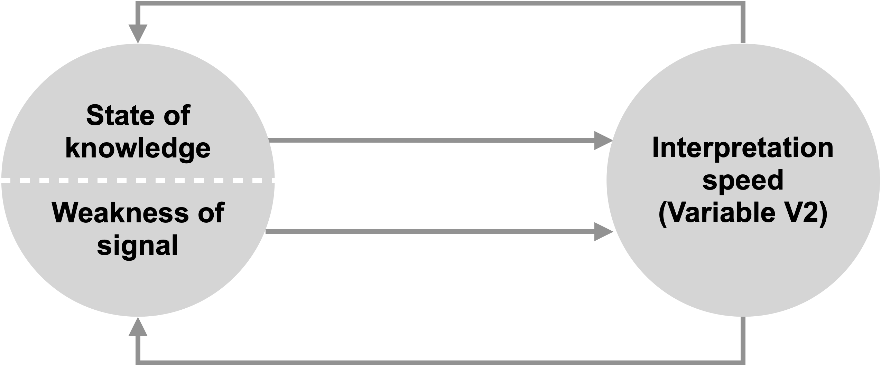

Figure 7. A less simplified relationship between weak signals and interpretation speed, in which the signal is split in state of knowledge and weakness to reveal their dynamic relationship with interpretation speed

Or, if weakness referred to the dissimilarity or distance of a signal to the observers' existing knowledge or expertise, one could argue that it would take both variables to affect interpretation speed (see Figure 8).

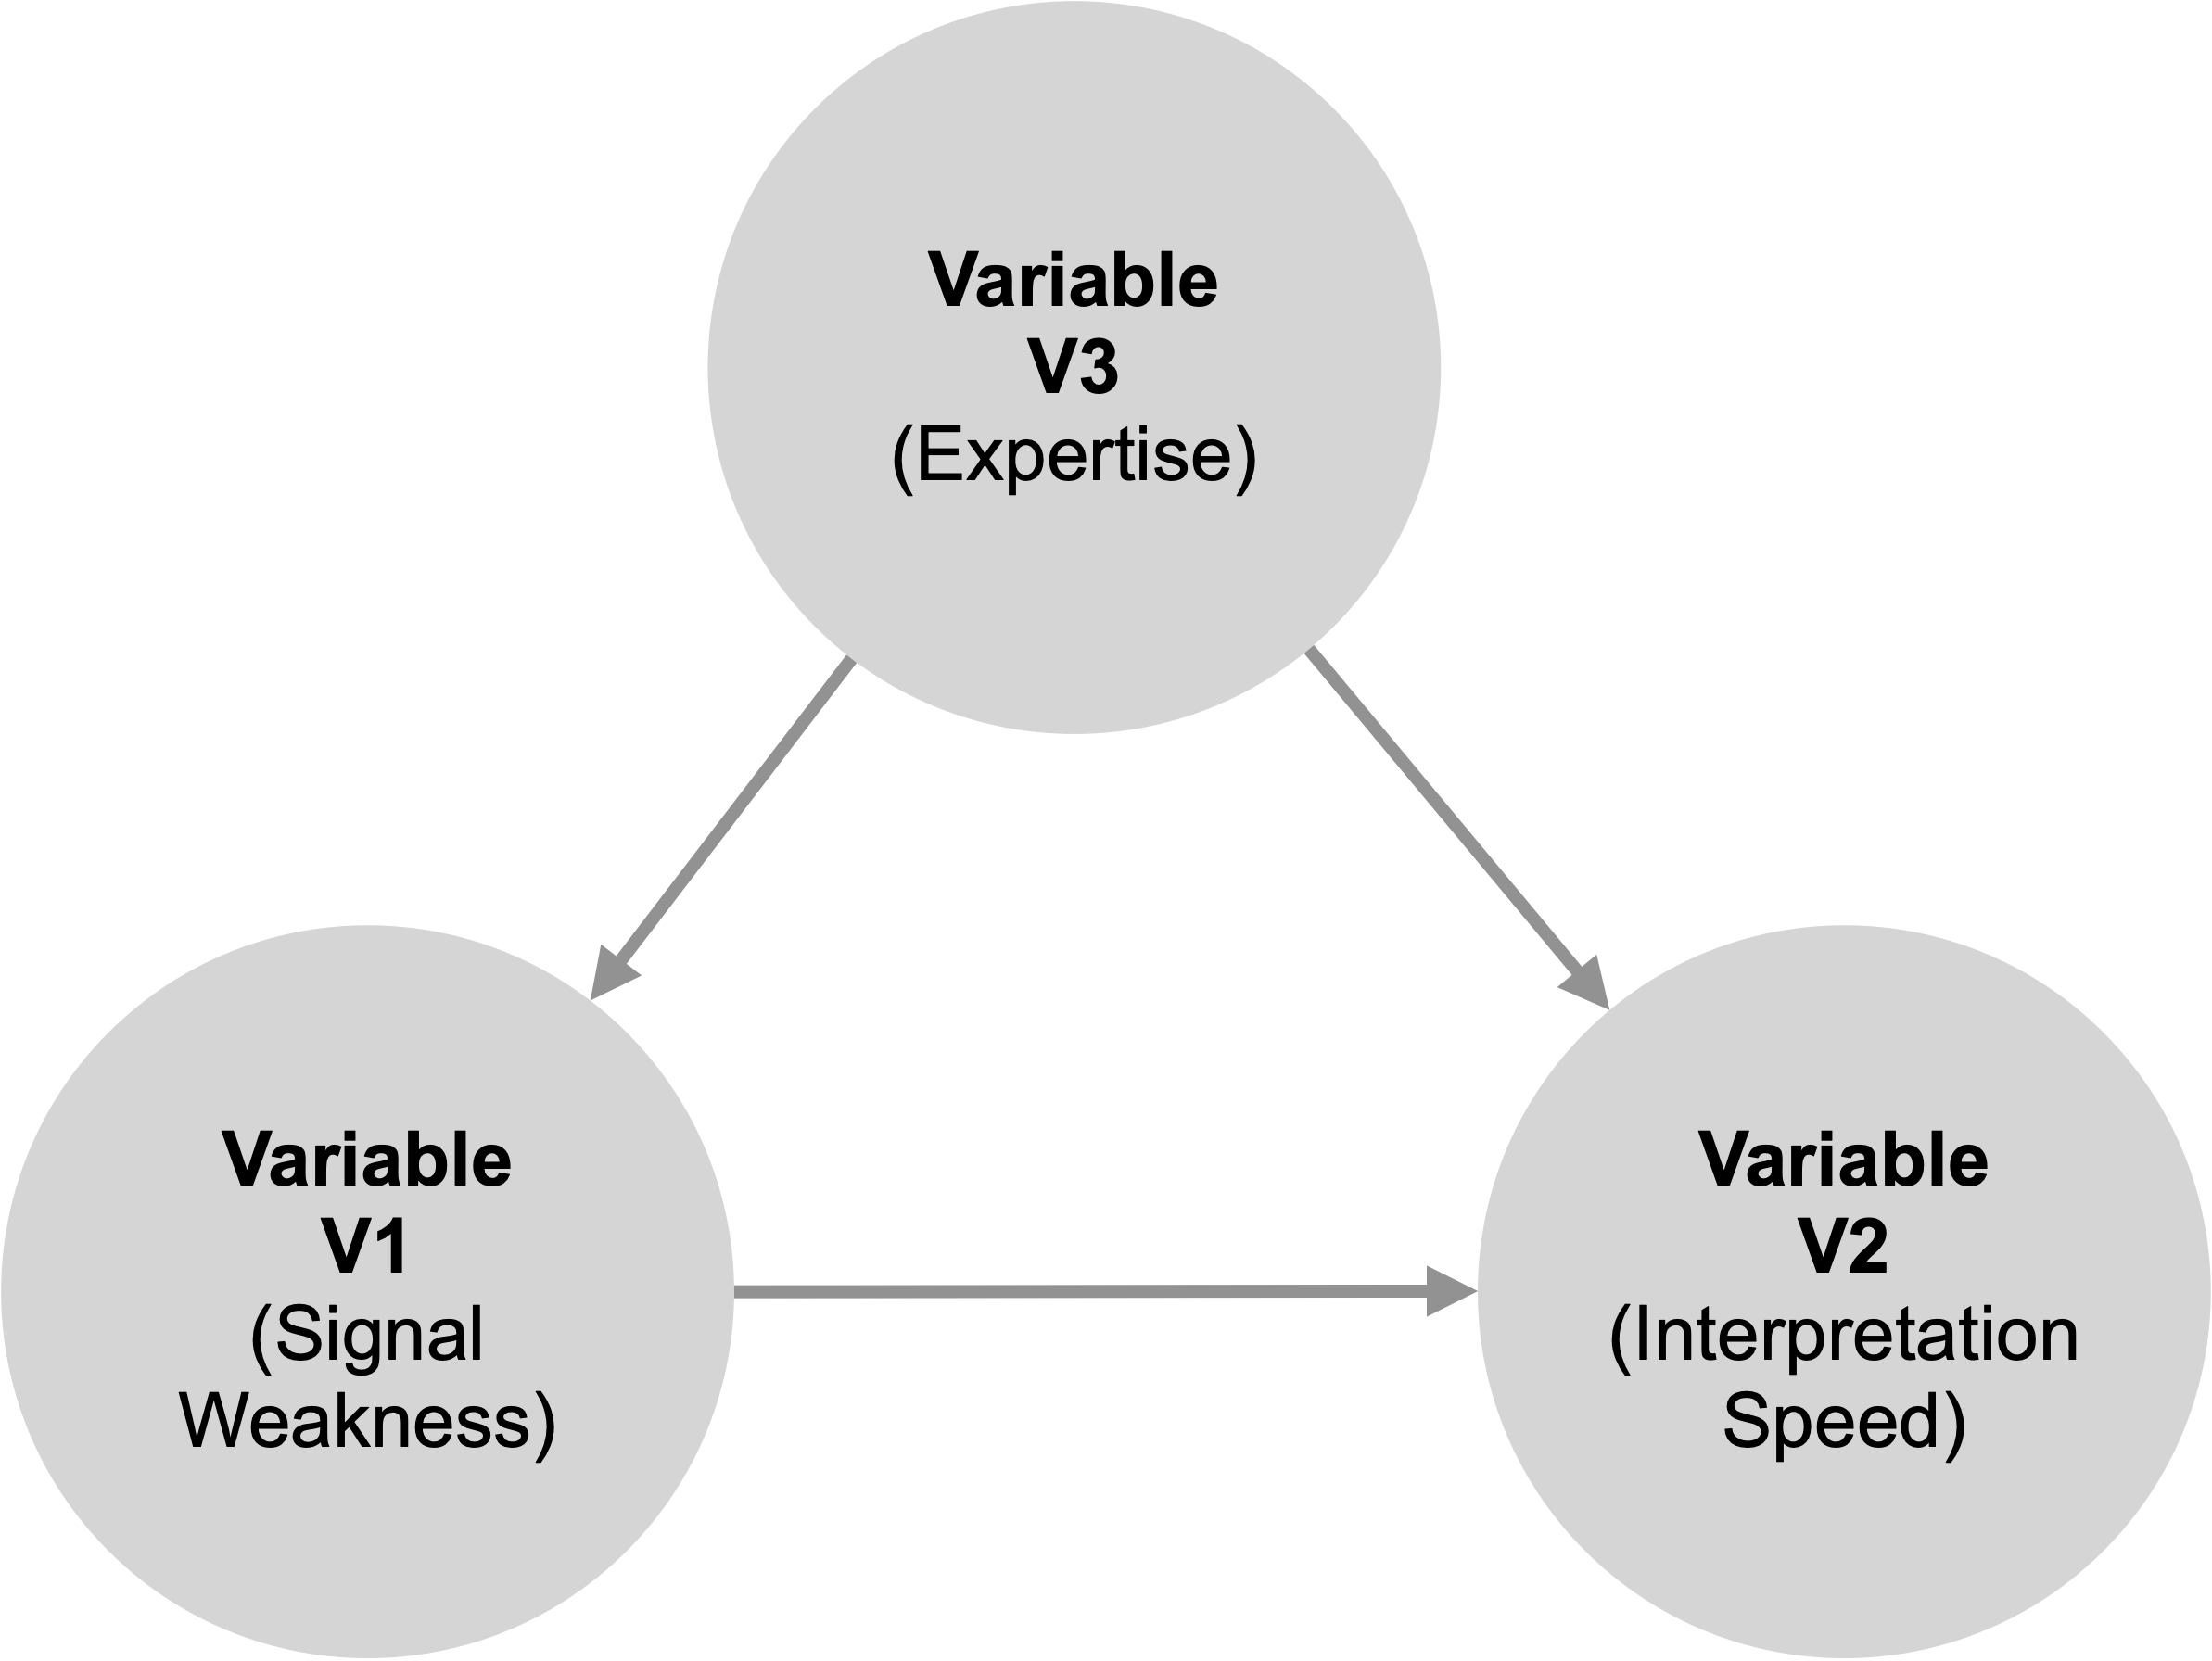
Figure 8. The relationship between weakness (variable 1) and interpretation speed (variable 2) can only be understood with reference to expertise (variable 3)

The singular linear relationship in Figure 6 is an arbitrary choice that ruled for decades and recently has been disproven. A study that used multiple levels of weakness discovered that the relationship between weakness and speed is not linear. Although strong signals were interpreted fast and weak signals much slower, extremely weak signals were very quickly dismissed as untrue, not relevant, or not urgent. Hence, the relationship appears curvilinear (van Veen, 2020).

Weak Signal Relationship Operationalization
We are taught that problems with relationship conceptualization will surface once we test relationship hypotheses, and frequently, they do. But like the proverbial black swan, it takes only one example to disprove an assumption. We gave that example already: the assumed relationship between weak signals and interpretation speed passed the tests. Only when weakness was disaggregated in levels, a curvilinear relationship could emerge.

Another example is the relationship between weak signals and search behavior. Many studies have revalidated the positive linear relationship between weak signals and information search frequency (Auster & Choo, 1993; Daft et al., 1988; Lesca et al., 2012). However, the curvilinearity also applies to the extremely weak signals: when signals are too unfamiliar, they're just dismissed, and search does not take place at all.

In the case of weak signals, we study the extraordinary, not the ordinary. By lack of clear insight into the factor(s) that define weakness, we conceptualize weak signals as any signal opposite of strong and apply the usual statistical procedures, like removing outliers during regression. But if a weak signal refers to the hard-to-recognize information that will impact the status quo in the future, we may be talking about precisely these outliers, if they appear at all. When operationalizing weak signal relationships, we should be wary of standard testing, and if outliers do surface, study the difference between them and the rest instead.

Oversimplification of the 'Innovativeness-Adoption' Model Context
It could be argued that a model is at its most advanced level when it represents a universal law. The collective studies on a conditional model are supposed to bring it closer to universality. Model refinements, limitations, moderating and modifying variables are the scientist's tools to advance models to universal validity. In the following paragraphs, we show that oversimplification occurs when contextual contingencies remain implicit or get discarded in subsequent studies.

In the case of innovativeness, contextual phenomena play an important role in adoption and diffusion processes. Engel et al. (1990, p. 696-697) indicate that the speed of diffusion depends on several contextual variables. For example, contextual variables include the competitive intensity of the innovation's leading supplier, supplier reputation, supplier's resource commitments, availability of standards for the innovation, coordination of and cooperation between complementary actors required to supply the innovation, and all of the innovation's complementary products and services. It is interesting to see that fast diffusion requires conditions to be optimal in the entire market system: on the supply side, the demand side, and the guiding institutions in a context where the supply- and demand-side actors operate. Neglecting all supply-side and other contextual variables makes the results of demand-side research incomparable. So, again, the body of knowledge is not progressing but stalled.

In short, we conclude that the relationship central to a vast domain in social scientific research, namely the relationship between the innovativeness of individuals and their adoption of innovations in a specific product category, is plagued by oversimplification.

Oversimplification of the Signal Weakness Context
Research on weak signals has been triggered by the aftermath of environmental shocks and the wish to see the next one earlier. Research into strategic surprises commenced after the second world war. Ansoff started his research into weak signals after the first OPEC-induced oil crisis in the 1970s. Others referred to the changing role of China in Hongkong (Ebrahimi, 2000) around the turn of the century or the credit crisis in 2008 (Ojala & Uskali, 2007; Schoemaker & Day, 2009), and future ones will undoubtedly be triggered by shocks like the pandemic, the war in Ukraine, or the expected digital revolution.

These shocks differ from natural disasters to political, economic, and societal discontinuities. Although the phenomenon under study always concentrates on how we can anticipate new shocks early, it cannot be ruled out that a shock's domain influences the model we study. After all, the military or political process dynamic is unlike that of the economic or scientific process. Therefore, a study should always disclose its model’s context.

The field of environmental uncertainty, which is purposefully multidisciplinary and strives to clarify how its findings connect to other fields (Van Dorsser et al., 2018) can teach us how the model context can be conceptualized. Environmental uncertainty is sometimes described in terms of two dimensions, complexity and dynamism, and their multiplication determines exactly how uncertain an environment is (Walker et al., 2003).

In the case of the relationship between weak signals and search behavior, confusing results can point to undisclosed contextual conditions, regardless of phenomenal conceptualization or relationship clarity. For instance, weakness in the sense of novelty or the difficulty in believing signal urgency or accuracy may depend on what signal receivers already know. Expert receivers like epidemiologists may assess signal urgency of COVID-19 differently than laypersons who see signals in light of the yearly common flu. Likewise, expert receivers may judge signal accuracy in light of the ingrained beliefs of decades of contrasting experience. In both cases, the prior knowledge of the receiver influences the relationship between signal weakness and search. Yet, to the authors' knowledge, a variable representing prior knowledge has not been included in weak signal studies.

Finally, rare are the studies that have incorporated dynamism of some sort (Thorleuchter & Van Den Poel, 2013; Yoon, 2012). In effect, that means that the field assumes models to be more or less context-independent, while especially the dynamism of weak signals should advocate a more holistic approach.

The oversimplification issues within the two cases were extrapolated into more generic issues. We first collected the issues per component and stage and then combined and extrapolated categories from the issues. Finally, the collection of categories and issues was tabulated into the classification framework described in the next section.

Classification of Model Oversimplification Issues

Individual studies are steps in the scientific journey towards more profound knowledge and theory building. Model simplification in one step can lead to issues when left unchecked in the next step. After several of those unchecked steps, our shared knowledge and theory suffer from severe oversimplification and thus diminishes in quality and functionality. Classification of issues in categories describing when, where in the model and how much oversimplification has occurred can help researchers check their work more efficiently for this problem.

Table 1 gives a helpful overview of oversimplification issues in three ways. Firstly, by reading the table from left to right, researchers can check new models for oversimplification per model component, stage, and captured complexity level (section 4.1). Secondly, by reading the table from right to left, researchers can detect possible oversimplification in existing models by its symptoms in literature reviews (section 4.2). Finally, reading column 3, researchers can determine their model's complexity level. By plotting a model in column 3, researchers can deliberately decide if the chosen level does justice to the real-world situation the model represents or if model complexity should move up or down one or more levels (section 4.3).

Checking New Models for Oversimplification
Reading table 2, columns 1-3, from left to right, researchers can check new models for oversimplification per model component, stage, and captured complexity level.

Table 2 separates models into three components in which simplification can occur. Firstly, complexities in the model phenomena (row 1), secondly in the relationship between phenomena (row 2), and finally in the model context (row 3). Issues can occur during two stages: model conceptualization and operationalization (column 2). Oversimplification (or overcomplication) occurs when the complexity captured by a model does not match real-world complexity close enough to remain a valid representation (column 3).

Conceptualization refers to how phenomena, relationships, and contexts are represented and defined in a model with variables and effect relationships. Operationalization describes how the variables and their effects are measured and assessed empirically. Oversimplification can stem from overly simple definitions and measurements.

We distinguish four levels of decreasing model simplicity. The first level describes simple, elegant models. The second level describes the models that have to incorporate more variables or dimensions to remain valid. The third level describes the models that acknowledge the interference of multiple overlapping variables or models for it to remain accurate. Finally, the fourth level describes the intricate models that accommodate systems of multi-dimensional models to remain valid over time. Oversimplification occurs when a given model should incorporate a higher level of complexity to remain valid.

Types of Phenomenal Oversimplification
When a one-dimensional variable represents a multi-dimensional phenomenon, special attention must be given to the original cloud of variables. When it is difficult to isolate a variable because natural or other obvious logic is lacking, chances are that oversimplification occurs.

For example, a one-dimensional choice may lack significant dimensions, or multiple variables may behave as dimensions of one variable. In both cases, dimensions determining the phenomenon remain hidden. That can become a validation problem when findings on a phenomenon are combined into a body of knowledge. For example, if studies looked at a partial phenomenon and these parts did not entirely overlap, one could question the validity of the findings. Sections 3.1 and 3.2 showed the confusion within the variables describing the innovativeness and signal weakness phenomena and how that could lead to erroneous assumptions and inconsistent results.

Types of Relationship Oversimplification
When variable dimensions remain hidden, the relationship with other variables suffers. For example, relationships show a singular linear behavior, which hides significant findings. Curve-linearity or other hidden aspects of relationships may surface when these relationships are multifaceted or aggregated for multiple dimensions. This, too, can become a problem in the validation of findings. Sections 3.3. and 3.4. showed myopia in the relationships between a characteristic (innovativeness; signal weakness) and speed of a behavior (innovation adoption and interpretation, respectively) and how that could lead to confusing results.

Types of Contextual Oversimplification
When contextual phenomena influencing a model receive a mere mention as model limitations, special attention must be given to all research using that model. If limitations were not accounted for in each repetition, significant information has been omitted, and findings may become misleading. Sections 3.5. and 3.6. showed that models must remain seen in their original context or be changed in accordance with contextual change. Diffusion of innovation has changed since the original model, and signal weakness effects vary depending on the prior knowledge of each signal observer.

Although table 2 cannot be seen as a complete and finite overview of issues, applying the table to the cases in section 3 suggests that it can serve as a detection tool. Using the table will help sensitize researchers to oversimplification issues and help them to make deliberate, explicit choices about their models. Describing these choices in their papers will help reduce oversimplification in shared theories and bodies of knowledge.

In the next section, we will apply the table to a model’s provenance: the underpinning theoretical or empirical models from literature.

Table 2. Classification of Issues in Model Oversimplification
Component | Stage | Issues in increasing levels of model complexity | Symptoms in literature
Phenomena  Choices about how to represent a phenomenon with variables: variable development and measurement.  Please find examples in sections 3.1. and 3.2. | Conceptualization  Are different (subsets of) dimensions required to describe the phenomenon accurately? | - The phenomenon can be described with an obvious one-dimensional variable.  - The phenomenon should be expressed in multiple dimensions but is conceptualized as one-dimensional.  - Phenomenon intricacy should result in multiple overlapping variables but is conceptualized in one variable.  - The phenomenon should be comprised of multiple partly overlapping multi-dimensional variables. | Direct indicator:  - An abundance of definitions emerges in the literature. Definitions cannot easily be combined.  - Different variable names are proposed for the same phenomenon.  - Different conceptualizations are proposed for the same variable.  - Different disciplines focus on different dimensions of a phenomenon, raising validation concerns.  Indirect indicator:  - Review articles ask for conceptual clarity in defining phenomena.
 | Operationalization  Are different items required to measure a phenomenon accurately? | - A single one-dimensional scale suffices.  - A multi-dimensional scale is required to capture different phenomenal aspects, but a one-dimensional scale is used instead.  - The variables should be measured with multiple overlapping (linked) scales to account for the underlying phenomenon's entire behavior.  - The variables should be measured with multiple overlapping (linked) multi-dimensional scales to account for the underlying phenomenon's entire behavior: The measurement affects relationships that can be assessed empirically, e.g., a binary variable can never lead to a curvilinear relationship. | Direct indicator:  - Many different ways to measure the phenomenon emerge in the literature (even for similar conceptualizations).  - The scaling of the variable does not reflect the levels in the phenomenon.  - The operationalization of the variable is mixed up with consequences of the variable or with co-evolving aspects of it.  Indirect indicator:  - Review articles ask for consistency in measuring variables.
Relationship  Choices about how variables affect each other: relationship direction and linearity.  Please find examples in sections 3.3. and 3.4. | Conceptualization  Can different relationships be hypothesized between the same phenomena in terms of direction and or linearity? | - A single one-directional linear relationship suffices.  - Different dimensions can lead to varying relationships in terms of direction and or linearity.  - The direction of a relationship (cause-effect) is misspecified, e.g., two-sided versus one-sided causality, covariation vs. causality.  - Multiple relationships are responsible for the behavior of related phenomena in different ways. | Direct indicator:  - Different disciplines build up their models around the same phenomenon.  Indirect indicators  - Siloed disciplinary perspectives and review articles ask for interdisciplinary collaboration.
 | Operationalization  Are different statistics required to reveal the true nature of relationships in terms of direction and or linearity? | - The method is accurate.  - The method assumes a particular type of relationship, e.g., some correlation measures assume a linear relationship.  - The method assumes that outlier removal will improve accuracy, yet outliers describe essential behaviors.  - The method assumes singular relationships instead of a system of relationships. | Direct indicator:  - Within the same discipline, empirical results regarding the same relationship yield different results.  - Meta-analysis in one discipline assesses inconsistent results.
Model Context  Choices about the interaction between a model and its context: model heterogeneity and dynamism.  Please find examples in sections 3.5. and 3.6. | Conceptualization  Are different variables influencing the relationship (e.g., moderators, mediators, or joint causes) required to keep a model accurate? | - The model represents a universal law.  - The heterogeneity of the context is simplified. Hence, relevant variables are omitted, and conditionality remains implicit.  - Dynamic relationships between variables or models are expressed as static. Hence, the model represents one instance of an interactive model.  - The effect of the variable time is ignored while intrinsic to the phenomenon. Hence, emerging effects remain implicit as well as temporal limits to model validity. | Direct indicator:  - Different disciplines build up their models around the same phenomenon.  Indirect indicators  - Siloed disciplinary perspectives and review articles ask for interdisciplinary collaboration.
 | Operationalization  Are different ways to measure or isolate variables and to compensate or deal with their effect required to reveal the actual behavior of the phenomena? | - The model can be measured independently from its context.  - An integrated measurement should reflect the effect of contextual variables on the primary relationship between phenomena.  - A holistic measurement should reflect that the starting point of reasoning determines what cause is and what effect.  - An infinite measurement should reflect how a model changes over time. | Direct indicator:  - Within the same discipline, empirical results regarding the same relationship yield different results.  - Meta-analysis in one discipline assesses inconsistent results.  - Context is made up of different variables in each research project.  Indirect indicators  - Per discipline, context is operationalized differently.

(Disclaimer: The conceptualization and operationalization issues in assessing the context's relationship and effect can hardly be separated. They can originate from conceptual and operational issues regarding the phenomena.)

Checking Underpinning Models for Oversimplification
Reading table 2 from right to left, researchers can detect possible oversimplification in existing models by the symptoms that emerge from literature reviews.

Table 2 lists symptoms from literature and separates them into direct and indirect symptoms. Direct symptoms are the actual references to an abundance of ways to define or measure the same phenomenon, confusing results, or meta-analyses. Indirect symptoms are appeals for clarity or collaboration within or between disciplines.
The cases about innovativeness and signal weakness (in section 3) illustrate the occurrence of these symptoms. The examples were deliberately chosen because they are opposites to a certain extent. Innovativeness is a mature research domain phenomenon with established paradigms and conceptualizations. Signal weakness is a phenomenon from a nascent domain with commonly accepted models and commonly noted conceptual issues. The cases refer to different research domains, but our analysis highlighted similar oversimplification issues. Therefore, we assume that these symptoms can be generalized across disciplines in the social sciences.

Symptoms of Phenomenal Oversimplification
When definitions or measures of a phenomenon have been oversimplified, studies will likely differ in the chosen dimensions for representing said phenomenon. The differentiation in definitions and measures is a byproduct of the difference in the focus of empirical studies on (parts or aspects of) a phenomenon in isolation. Studies build on one another to fill knowledge gaps, and thus foci change slightly. At the individual study level, the choices resulting from focus are logical and grounded in previous research. However, at the overarching level, definitions and measures may -at a certain point- no longer represent the same phenomenon or phenomenal dimension. At that point, any subsequent study should be very careful with the grounding of its model in underpinning literature. Before grounding can take place in those cases, earlier definitions and measures should be analyzed to reveal a possible significant lack of overlap.

A large number of definitions of a particular phenomenon as a fraction of all the articles on that phenomenon directly indicates the co-existence of significantly different definitions. Review articles requesting clarity and unification are an indirect indicator of phenomenal oversimplification.

A multitude of conceptualizations can occur between and within disciplines. The same phenomenon can have multiple names, conceptualizations, and operationalizations between disciplines. Within disciplines, a phenomenon can be conceptualized and operationalized with somewhat arbitrary or overlapping dimensions. Multidisciplinarity is not a symptom of oversimplification, but when paired with inconsistent results, oversimplification is a plausible cause.

In section 3, we demonstrated that many alternative definitions of individuals' innovativeness have co-existed for decades. For signal weakness, we showed that over 60 different conceptualizations emerged since the term's coinage in 1975. In both cases, this led to oversimplification issues.

Symptoms of Relationship Oversimplification
The second set of symptoms revolves around the relationship in focus. The type and form of the relationship can be misspecified. For example, a cause-and-effect relationship assumes a one-way relationship from the cause to the effect, yet other types of relationships are also possible.

When phenomena consist of multiple dimensions, but research focuses on different singular dimensions, then inconsistent results regarding their measurement and relationships are expected. A literature review showing confusing results is a red flag for oversimplification.

Researchers are inclined to simplify phenomenal intricacies so that their variables focus on phenomena' main characteristics and behaviors without distorting the assessment of the relationships between phenomena. This simplification is, almost inevitably, a function of the context and timeframe in which researchers operate. Since researchers explore similar relationships between phenomena in different contexts and timeframes, the inconsistency of their results is inevitable.

Symptoms of Model Contextual Oversimplification
A final set of symptoms revolves around the context in which the relationship between the phenomena is assessed. The context may include other phenomena affecting the cause-and-effect relationship.

In the example of innovativeness, we have shown how the context and timeframe of research on innovation diffusion have caused particular simplifications. The first authors, Ryan and Gross, meticulously described the context and timeframe in which they formulated their innovation diffusion model: US farmers adopting hybrid corn around 1940 (Ryan and Gross, 1948).

Moreover, the simplifications researchers adopt are a function of their research’s goal. Their goal determines the perspective from which they observe the phenomena, relationship, and context and the level of analysis they choose. Therefore, simplifications will vary widely because goals and researchers' perspectives vary. For example, economic theories serve varying purposes, like explaining unemployment and inflation as well as innovativeness in a country. The goal is for researchers to emphasize particular phenomena and discard other phenomena; hence, economic theories conceptualize and operationalize a country entirely differently. An example of varying perspectives is provided by differences between models of innovation in an industry seen from a government's or a company's perspective.

Checking findings from a systematic literature review for oversimplification symptoms may prompt researchers to dig deeper by reading the table from right to left. If a symptom mentioned in table 1, column 4 surfaces, columns 1-3 may shed light on where, when, and how much oversimplification occurred in individual studies. A deeper insight into its causes can help researchers find ways, logically or empirically, to reconcile the phenomenal, relationship, or contextual differences at the individual level instead of adding to the confusion at the overarching level.

In the next section, we will apply the table to possible up- or downgrades of model complexity.

Checking Underpinning Models for Oversimplification
Reading table 2, column 3, researchers can determine the level of complexity in model components and stages and deliberately decide if the chosen level does justice to the real-world situation the components represent.

When symptoms of oversimplification occur, the first step is to reflect on the extent of captured complexity in model components.

To manage oversimplification, researchers must be aware that a continuous progression of complexity exists. Real-world complexity ranges from none to infinite, and its existence can remain unseen to wholly understood. Hence, models can vary significantly in the extent of complexity captured in the model components.

To manage oversimplification, we have aggregated component complexity into model complexity, as shown in Table 3. We distinguish four levels of captured complexity. A 'clear model' is presented in the first level, containing two obvious one-dimensional variables. One variable has a linear effect on the other, independent of context. In the fourth level, a 'cryptic model' is presented in which multiple overlapping and multi-dimensional variables have chaotic relationships in a fuzzy context.

Levels of intricacies differ in the detailing a model requires to keep resembling the real-world problem it tries to replicate. The determinism of the correct level in the case of a particular research project is done through comparison with the description of the intricacies per category per level.

Table 3. Model Complexity
 | Component | Level of Captured Complexity
 |  | Level 1 | Level 2 | Level 3 | Level 4
Determinism | Model | Clear Model | Complex Model | Clouded Model | Cryptic Model
 | Phenomena | Obvious variables | Multidimensional variables | Multiple overlapping variables | Multiple multi-dimensional overlapping variables
 | Relationships | One-directional linear relationship | Multifaceted one-directional relationship | Bi-directional curvilinear relationships | Chaotic relationships
 | Context | Context independent | Integrated contextual variables | Dynamic system of models | Fuzzy model or system

Mere complexity does not cause symptoms of oversimplification. As long as complexity can be unraveled in parts that are observed the same way by researchers across disciplines and over time, these symptoms do not emerge. On the other hand, if these symptoms are pervasive or persistent, likely, oversimplification issues are too.

Table 3 suggests that models can be categorized in levels of captured complexity and that moving up or down between levels can help researchers find a complexity sweet spot. The sweet spot refers to the lowest level of captured complexity to represent a real-world phenomenon and still significantly overlaps with earlier studies for building theory and knowledge.

Conclusion and discussion

In the social sciences, models capture the behavior of social phenomena in the most spartan form. Real-world complexity and dynamism may be reduced to two variables and their hypothetical relationship and then tested for hypothesis accuracy. It is precisely this reduction that allows us to do controllable research. We strive for the simplest accurate version possible, the most elegant model. Rigorous procedures bind reduction to avoid mistakes and misinterpretation. However, logical choices at the level of individual studies may lead to gross oversimplification errors at the discipline level. In turn, literature reviews unchecked for oversimplification errors can lead to misguided choices in subsequent studies.

We developed a classification of oversimplification issues that researchers can use to check their work in three ways. Firstly, researchers can check new models for possible oversimplification in model components, stages of development, and captured complexity. Secondly, researchers can check existing models for oversimplification by looking for direct and indirect references to its symptoms in literature reviews. Thirdly, researchers can locate the simplification/complexity sweet spot: the lowest level of captured complexity while the model still represents the real-world phenomenon and remains integrated into earlier conceptualizations.

We began exploring the problem of oversimplification with the most basic model: that of two variables and their relationship. The issues of a simple model can then serve as a reference for exploring more complex models, which may or may not suffer from the same oversimplification. We used cases from two disciplines of social sciences that can be seen as opposites in field maturity but similar in their focus on factors determining organizational change. Each case consisted of a broadly accepted two-variable model. Analysis of the cases resulted in the emergence of the same issues, suggesting that these were generalizable across organizational and managerial research disciplines.

Further anecdotal evidence for this assumption was found in the handbook of marketing scales by Bruner and Gordon (2012). Almost all phenomena are conceptualized in slightly different versions. One of the most striking examples is the concept' attitude of individuals', for which 65 different scales or operationalizations are presented.

Signals of Possible Oversimplifications Within Domains
We discussed the effects on subsequent research if oversimplification is uncorrected for the three model components. For instance, when phenomenal intricacies remain unaddressed, the need to redefine persists. Literature reviews will include studies and reviews that refer to the many definitions and appeal to phenomenal clarity. Such appeals could serve as an indicator that uncorrected intricacies are an issue. When relationship intricacies remain unaddressed, confusing or conflicting results can surface, or the gap between findings and the real-world situation remains challenging to bridge. A domain's combined gap analyses can serve as an indicator of such intricacies. Finally, when contextual intricacies remain unaddressed, models can become established without their caveats and result in a house-of-cards body of knowledge that surfaces with model refinements. The abundance of these effects in extant literature emphasizes how persistent and pervasive oversimplifications are.

Interrelatedness of Conceptualization and Operationalization Stages
We distinguished between conceptualization and operationalization oversimplifications of model components. At a theoretical level, the separation in all three categories made sense, but less so in exploring the two examples. The separation in conceptualization and operationalization was already difficult for phenomena. In the case of the innovativeness phenomenon, individual innovativeness was sometimes assessed in terms of characteristics that co-evolved with it (for example, age and level of education). On other occasions, the innovativeness of an individual was assessed as an innate personal characteristic that causes it (for example, the degree of cosmopolitism) or in terms of its consequence (the timing of adoption of an innovation). Conceptualization and operationalization seemed to mesh in the case of an individual's innovativeness.

The separation in conceptualization and operationalization was even more difficult in relationship and contextual complexity. For example, in the case of signal weakness, the operationalization of the phenomenon in a dichotomous variable determined the relationship and how it could be measured. That way, the operationalization caused relationship oversimplification because it kept the curvilinearity of the relationship hidden until a more intricate level was explored. This led us to assume that phenomenal oversimplification will not always surface during validity tests at lower intricacy levels. Whether or not this assumption is valid should be the subject of future research. In the meantime, the interrelatedness emphasizes the severity of oversimplification effects of one category on the others.

Effects of Unaddressed Oversimplifications
When phenomenal oversimplifications, indicated by a growing lack of common definitions and operationalizations, are left unattended, validation of findings could become a problem. When conceptualizations and operationalizations partially overlap across the studies that researchers are building upon, they must clarify whether their reasoning is based on the overlap or not. When tens of definitions exist, statistical analysis of the distance between definition aspects should replace logical deduction. When such an analysis does not happen, studies lack construct validity.

More complex relationships like curvilinearity can remain hidden when construct validity is an issue. If this is left unattended, studies lack internal and predictive validity. When contextual oversimplification is an issue, models have been separated from significant inherent conditions and can keep moderating and mediating variables hidden. If that is left unattended, studies lack external validity. When the findings of studies lacking in validity are used for new studies (as opposed to repetitive studies to check validity), a domain's body of knowledge and theory building are in danger, and progress is shaky at best.

Suggestions to Address Oversimplifications
It seems evident that researchers pay more attention to indicators like definition abundance, confusing or conflicting results, persistent gaps between findings and real-world situations, or serial model refinement. However, oversimplification will not always surface despite our attention to indicators. In the case of signal weakness, only phenomenal oversimplification was noted but left to exist because every subsequent study created its definition from literature and logical deduction. The dichotomous character of the variables representing weak signals suppressed relationship and contextual complexity, and decades went by without any confusing or conflicting results surfacing. We, therefore, suggest that researchers, whenever they find indications of oversimplification, resort to statistical analysis to let complexities surface instead of moving to the next logical simplification. A systematic way to make such complexity visible for variable definitions is provided by (Barbara L van Veen & Ortt, 2021).

Future Research Avenues
We have already hinted at several avenues of future research. Firstly, our assumption that the two cases represent a persistent and pervasive problem in the social sciences should receive a statistical basis.

Secondly, the interrelatedness of the conceptualization and operationalization of phenomena, their relationships, and model contexts in simple models should be clarified further. Findings will help establish if hidden complexity should be solved at the category, conceptual, or operational levels or just for specific combinations. It will also illuminate which statistical methods are preferable.

Thirdly, more complex models can be checked for oversimplification and its effects. More complex models could suffer more due to the addition of phenomena, variables, and relationships. However, more complex models could also suffer less because they have already captured more complexity. Only research will tell us how more intricate models relate to the simple model discussed here.

Fourthly, our list of issues is by no means finished. For example, we did not include the oversimplification issues that can occur when a relationship is conceptualized at certain levels of analysis. We suspect many decisions in a study’s set-up can lead to oversimplification, but further research should clarify if an exhaustive list is possible or necessary.

Finally, a method could be developed to help mitigate hidden oversimplification and its effects. At this point, we assume that normative models can benefit from an explorative check. For instance, a statistical exploration of possible variables could let a competent variable surface from data without a natural or apparent logical definition. Similarly, combining statistical and logical data could let more complex models appear. In both cases, variables and their relationships would suffer less from the implicit oversimplifications inherited from earlier findings. Establishing the value of an explorative phase preceding a normative study is also an excellent first step in future research.

To conclude, we frankly admit to being no better than the simplified examples we discussed.

References
Anderson, M. H., & Nichols, M. L. (2007). Information gathering and changes in threat and opportunity perceptions. Journal of Management Studies, 44(3), 367-387.
Ansoff, H. I. (1975). Managing strategic surprise by response to weak signals. California Management Review, 18(000002), 21-33. <Go to ISI>://WOS:A1975BK11800002
Ansoff, H. I. (1979). Strategic Management. Palgrave Macmillan UK. https://doi.org/10.1007/978-1-349-02971-6
Auster, E., & Choo, C. W. (1993). Environmental Scanning by CEO's in Two Canadian Industries. Journal of the American Society for Information Science, 44(4), 194-203. https://doi.org/10.1002/(sici)1097-4571(199305)44:4<194::aid-asi2>3.0.co;2-1
Barreto, I. (2012). Solving the entrepreneurial puzzle: The role of entrepreneurial interpretation in opportunity formation and related processes. Journal of Management Studies, 49(2), 356-380.
Battistella, C. (2014). The organisation of Corporate Foresight: A multiple case study in the telecommunication industry. Technological Forecasting and Social Change, 87. https://doi.org/10.1016/j.techfore.2013.10.022
Bearden, W. O., & Netemeyer, R. G. (1999). Handbook of marketing scales: Multi-item measures for marketing and consumer behavior research. Sage.
Blanco, S., & Lesca, H. (1997). Environmental scanning: Designing a collective learning process to track down weak signals. <Go to ISI>://WOS:000078771300028
Bliese, P. D., & Ployhart, R. E. (2002). Growth modeling using random coefficient models: Model building, testing, and illustrations. Organizational Research Methods, 5(4), 362-387.
Busse, C., Kach, A. P., & Wagner, S. M. (2017). Boundary conditions: What they are, how to explore them, why we need them, and when to consider them. Organizational Research Methods, 20(4), 574-609.
Carbonell, J., Sánchez-Esguevillas, A., & Carro, B. (2015). Assessing emerging issues. The external and internal approach. Futures, 73, 12-21. https://doi.org/10.1016/J.FUTURES.2015.07.015
Daft, R. L., Sormunen, J., & Parks, D. (1988). Chief executive scanning, environmental characteristics, and company performance: an empirical study. Strategic Management Journal, 9(2), 123-139.
Dedehayir, O., Ortt, R. J., Riverola, C., & Miralles, F. (2020). Innovators and early adopters in the diffusion of innovations: A literature review. Digital Disruptive Innovation, 85-115.
Dee Dickerson, M., & Gentry, J. W. (1983). Characteristics of adopters and non-adopters of home computers. Journal of consumer Research, 10(2), 225-235.
Del Giudice, M. (2021). Are complex causal models less likely to be true than simple ones? A critical comment on Trafimow (2017). Behavior Research Methods, 53(3), 1077-1080.
Dutton, J. E. (1993). Interpretations on Automatic - a Different View of Strategic Issue Diagnosis. Journal of Management Studies, 30(3), 339-357. https://doi.org/DOI 10.1111/j.1467-6486.1993.tb00308.x
Ebrahimi, B. P. (2000). Perceived strategic uncertainty and environmental scanning behavior of Hong Kong Chinese executives. Journal of Business Research, 49(1), 67-77. https://doi.org/10.1016/s0148-2963(98)00120-9
Eisenhardt, K. M. (1989a). Building theories from case study research. Academy of Management Review, 14(4), 532-550.
Eisenhardt, K. M. (1989b). Making fast strategic decisions in high-velocity environments. Academy of management Journal, 32(3), 543-576.
Eisenhardt, K. M., & Graebner, M. E. (2007). Theory building from cases: Opportunities and challenges. Academy of management Journal, 50(1), 25-32.
Elenkov, D. S. (1997). Strategic uncertainty and environmental scanning: The case for institutional influences on scanning behavior. Strategic Management Journal, 18(4), 287-302.
Engel, J., Blackwell, R., & Miniard, P. (1990). Consumer behavior (ed.) Chicago. In: Dryden Press. Retrieved from http://trove. nla. gov. au/work/10524553.
Fahey, L., & King, W. R. (1977). Environmental scanning for corporate planning. Business Horizons, 20(4), 61-71.
Foxall, G. R., Goldsmith, R. E., & Brown, S. (1998). Consumer psychology for marketing (Vol. 1). Cengage Learning EMEA.
Frank, R., Massey, W., & Wind, Y. (1972). Market Segmentation, Englewood Cliffs, NJ: Pentice-Hall. In: Inc.
Goldsmith, R. E., & Hofacker, C. F. (1991). Measuring consumer innovativeness. Journal of the academy of marketing science, 19(3), 209-221.
Hayes, A. F. (2012). PROCESS: A versatile computational tool for observed variable mediation, moderation, and conditional process modeling. In: University of Kansas, KS.
Hiltunen, E. (2008). The future sign and its three dimensions. Futures, 40(3), 247-260.
Holopainen, M., & Toivonen, M. (2012). Weak signals: Ansoff today. Futures, 44(3), 198-205. https://doi.org/http://dx.doi.org/10.1016/j.futures.2011.10.002
Ilmola, L., & Kuusi, O. (2006). Filters of weak signals hinder foresight: Monitoring weak signals efficiently in corporate decision-making. Futures, 38(8), 908-924. https://doi.org/10.1016/j.futures.2005.12.019
Jackson, S. E., & Dutton, J. E. (1988). Discerning threats and opportunities. Administrative Science Quarterly, 33(3), 370-387. https://doi.org/10.2307/2392714
Kaivo-oja, J. (2012). Weak signals analysis, knowledge management theory and systemic socio-cultural transitions. Futures, 44(3), 206-217. https://doi.org/10.1016/j.futures.2011.10.003
Kassarjian, H. H. (1971). Personality and consumer behavior: A review. Journal of marketing Research, 8(4), 409-418.
Kiss, A. N., & Barr, P. S. (2015). New venture strategic adaptation: The interplay of belief structures and industry context. Strategic Management Journal, 36(8). https://doi.org/10.1002/smj.2285
Landis, R. S., Beal, D. J., & Tesluk, P. E. (2000). A comparison of approaches to forming composite measures in structural equation models. Organizational Research Methods, 3(2), 186-207.
Lesca, N., Caron-Fasan, M. L., & Falcy, S. (2012). How managers interpret scanning information. Information & Management, 49(2), 126-134. https://doi.org/10.1016/j.im.2012.01.004
MacKinnon, D. P. (2011). Integrating mediators and moderators in research design. Research on social work practice, 21(6), 675-681.
Mischel, W. (1969). Continuity and change in personality. American Psychologist, 24(11), 1012.
Nadkarni, S., & Barr, P. S. (2008). Environmental context, managerial cognition, and strategic action: an integrated view. Strategic Management Journal, 29(13), 1395-1427. https://doi.org/10.1002/smj.717
Ojala, J., & Uskali, T. (2007). Any weak signals?: the New York Times and the stock market crashes of 1929, 1987 and 2000. Information flows: new approaches in the historical study of business information, 103-136.
Ortt, R., Dedehayir, O., Miralles, F., & Riverola, C. (2017). Innovators and early adopters in the diffusion of innovations: A literature review. ISPIM Conference Proceedings,
Park, C. W., Mothersbaugh, D. L., & Feick, L. (1994). Consumer knowledge assessment. Journal of consumer Research, 21(1), 71-82.
Perkins, D. N., & Grotzer, T. A. (2005). Dimensions of causal understanding: The role of complex causal models in students' understanding of science.
Rhyne, L. C. (1985). The Relationship of Information Usage Characteristics to Planning System Sophistication: An Empirical Examination. Strategic Management Journal, 6(4), 319-337. http://www.jstor.org/stable/2485938
Robertson, T. S. (1971). Innovative behavior and communication. Holt McDougal.
Rogers, E. M. (1983). Diffusion of innovation. Canada. In: The Free Press, A Division of Macmillan Publishing Co., Inc. New York.
Rogers, E. M., & Shoemaker, F. F. (1971). Communication of Innovations; A Cross-Cultural Approach.
Rohrbeck, R., & Kum, M. E. (2018). Corporate foresight and its impact on firm performance: A longitudinal analysis. Technological Forecasting and Social Change, 129, 105-116.
Rowe, E., Wright, G., & Derbyshire, J. (2017). Enhancing horizon scanning by utilizing pre-developed scenarios: Analysis of current practice and specification of a process improvement to aid the identification of important ‘weak signals’. Technological Forecasting and Social Change, 125, 224-235.
Ryan, B., & Gross, N. C. (1943). The diffusion of hybrid seed corn in two Iowa communities. Rural sociology, 8(1), 15-15.
Saritas, O., & Smith, J. E. (2011). The Big Picture - trends, drivers, wild cards, discontinuities and weak signals. Futures, 43(3), 292-312. https://doi.org/10.1016/j.futures.2010.11.007
Saylors, R., & Trafimow, D. (2021). Why the increasing use of complex causal models is a problem: On the danger sophisticated theoretical narratives pose to truth. Organizational Research Methods, 24(3), 616-629.
Schoemaker, P. J. H., & Day, G. S. (2009). How to Make Sense of Weak Signals. Mit Sloan Management Review, 50(3), 81-+. <Go to ISI>://WOS:000265012500018
Schoemaker, P. J. H., Day, G. S., & Snyder, S. A. (2013). Integrating organizational networks, weak signals, strategic radars and scenario planning. Technological Forecasting and Social Change, 80(4), 815-824. https://doi.org/10.1016/j.techfore.2012.10.020
Schoenenberger, L., Schmid, A., Ansah, J., & Schwaninger, M. (2017). The challenge of model complexity: improving the interpretation of large causal models through variety filters. System dynamics review, 33(2), 112-137.
Schwarz, J. O., Kroehl, R., & Heiko, A. (2014). Novels and novelty in trend research—Using novels to perceive weak signals and transfer frames of reference. Technological Forecasting and Social Change, 84, 66-73.
Summers, J. O. (1972). Media exposure patterns of consumer innovators. Journal of Marketing, 36(1), 43-49.
Tapinos, E., & Pyper, N. (2017). Forward looking analysis: Investigating how individuals ‘do’ foresight and make sense of the future. Technological Forecasting and Social Change. https://doi.org/https://doi.org/10.1016/j.techfore.2017.04.025
Taylor, A. B., MacKinnon, D. P., & Tein, J.-Y. (2008). Tests of the three-path mediated effect. Organizational Research Methods, 11(2), 241-269.
Thorleuchter, D., & Van Den Poel, D. (2013). Weak signal identification with semantic web mining. Expert Systems with Applications, 40(12). https://doi.org/10.1016/j.eswa.2013.03.002
Thorleuchter, D., & Van den Poel, D. (2015). Idea mining for web-based weak signal detection. Futures, 66, 25-34. https://doi.org/10.1016/J.FUTURES.2014.12.007
Van Dorsser, C., Walker, W. E., Taneja, P., & Marchau, V. A. W. J. (2018). Improving the link between the futures field and policymaking. Futures, 104, 75-84.
van Veen, B. L. (2020). Straws That Tell the Wind: Top-Manager Perception of Distant Signals of the Future. In: Delft University of Technology.
van Veen, B. L., & Ortt, J. R. (2021). Unifying weak signals definitions to improve construct understanding. Futures, 134, 102837-102837.
van Veen, B. L., Ortt, J. R., & Badke-Schaub, P. G. (2019). Compensating for perceptual filters in weak signal assessments. Futures, 108. https://doi.org/10.1016/j.futures.2019.02.018
von Groddeck, V., & Schwarz, J. O. (2013). Perceiving megatrends as empty signifiers: A discourse-theoretical interpretation of trend management. Futures, 47, 28-37. https://doi.org/10.1016/j.futures.2013.01.004
Walker, W. E., Harremoës, P., Rotmans, J., Van Der Sluijs, J. P., Van Asselt, M. B. A., Janssen, P., & Krayer von Krauss, M. P. (2003). Defining uncertainty: a conceptual basis for uncertainty management in model-based decision support. Integrated assessment, 4(1), 5-17.
Warren, W. E., Abercrombie, C., & Berl, R. L. (1988). Characteristics of adopters and nonadopters of alternative residential long-distance telephone services. ACR North American Advances.
Weick, K. E. (1995). Sensemaking in organizations (Vol. 3). Sage.
Wright, S. (1921). Correlation and causation.
Yoon, J. (2012). Detecting weak signals for long-term business opportunities using text mining of Web news. Expert Systems with Applications, 39(16), 12543-12550.

